Insight Team Briefing  August 2026 | 

ONS Mid-2025 Population Estimates
- Introduction

  - On 29th July 2026, ONS released the mid 2025 population estimate for Hull. This is an estimate of the resident population on 30 June 2025.

  - Revisions have also been made to mid-2022, mid-2023, and mid-2024 population estimates to incorporate improved international migration data.

  - The mid 2025 population estimate for Hull is 273,257.

  - This is a decrease of 1,470 people (-0.5%) compared to the revised mid-2024 estimate.

- Key Points to Note

  - Hull’s population was estimated at 273,257 in mid-2025, a decrease of 1,470 residents (-0.5%) from the revised 2024 estimate. This follows three years of exceptionally strong population growth and should be viewed as a moderation of recent growth rather than a reversal of the city's longer-term recovery since 2002.

  - Recent population growth has been driven overwhelmingly by international migration. The exceptionally high levels of net international migration recorded between 2021 and 2024 offset continuing losses through internal migration and a weakening contribution from natural change. The reduction in international migration during 2024-25 was the principal reason for the population decline recorded in the latest estimates.

  - Hull's population is becoming increasingly reliant on international migration to sustain growth. Lower birth rates, an ageing population and a narrowing gap between births and deaths mean that natural change now contributes far less to population growth than it did historically.

  - Internal migration continues to represent Hull's largest recurring source of population loss. While the city successfully attracts young adults through education, training and early employment opportunities, it continues to lose many residents during career progression, family formation and child-rearing stages, particularly to neighbouring authorities such as East Riding of Yorkshire and larger urban centres offering wider employment opportunities.

  - Hull retains a younger age profile than England, Yorkshire and the Humber and neighbouring authorities. However, the city continues to age, with growth increasingly concentrated amongst older age groups and declining numbers of young children. As a result, the dependency ratio continues to rise, driven principally by growth in the population aged 65 and over.

  - Comparison with the 2022-based population projections suggests that the longer-term demographic outlook for Hull remains broadly unchanged. Although population growth temporarily exceeded projections because of higher-than-expected international migration, both the total population and age structure had largely returned to the projected trajectory by 2025.

  - The estimates highlight three key long-term demographic challenges for the city: sustaining population growth in the context of lower birth rates, improving the retention of working-age residents and families, and responding to the increasing demands associated with an ageing population.

- Actions

  - Detailed breakdown of the population changes will be shared with all Services to ensure that Council documents and indicators use current population data.

  - Services should consider the impacts on future business planning, service design and delivery, and policy development.

- Population Growth

  - Chart 1 (below) shows the total population in Hull between 1981 and 2025.

Chart 1: Total Population in Hull 1981 – 2025

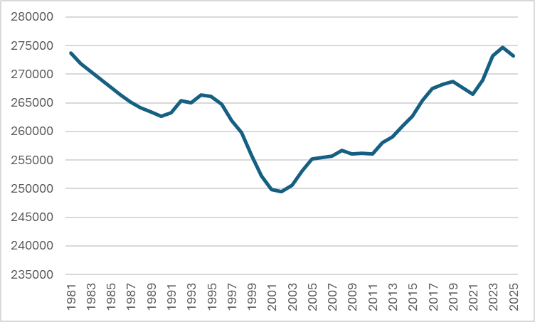

Source: ONS Mid-Year Population Estimates 1981 – 2025

  - Hull's population was estimated at 273,257 residents in 2025, only 443 fewer residents than in 1981 (273,700). Although this suggests little overall change over the last 44 years, it masks a significant period of population decline followed by a prolonged period of recovery and growth, reflecting major demographic, economic and migration-related changes within the city.

  - Between 1981 and 2002, Hull's population fell from 273,700 to 249,463, a reduction of 24,237 residents (8.9%). This period was characterised by industrial restructuring, changes in the local labour market and sustained net population outflow, trends that were common across many northern urban areas.

  - Population decline accelerated during the late 1990s. Between 1996 and 2000, the city lost 12,429 residents, accounting for more than half of the total population decline recorded between 1981 and 2002. The largest annual reduction occurred between 1998 and 1999, when the population fell by 3,892 residents.

  - Hull reached its lowest recorded population in 2002, at 249,463 residents, representing a loss of almost one in every eleven residents compared with 1981

  - Following its population low point in 2002, Hull entered a prolonged period of demographic recovery. Between 2002 and 2019, the population increased by 19,286 residents, recovering around 80% of the population lost during the previous two decades and reversing a long-established trend of decline.

  - Population growth during the 2000s and 2010s coincided with increased international migration, including migration from Central and Eastern European countries following successive rounds of European Union accession from 2004 onwards. Growth was also supported by the city's higher education sector and wider demographic change.

  - Growth accelerated during the 2010s. Between 2012 and 2019, Hull's population increased by 10,664 residents, with annual population increases generally stronger than those recorded during the previous decade.

  - Although the 2016 EU Referendum and subsequent changes to migration policy altered national international migration patterns, Hull's population continued to grow during this period, increasing from 265,338 residents in 2016 to 268,749 residents in 2019.

  - After almost two decades of growth, Hull experienced a temporary decline between 2019 and 2021, with the population falling by 2,233 residents. This period coincided with the disruption associated with the COVID-19 pandemic, including changes in migration, elevated mortality and reduced population mobility.

  - Following the pandemic period, Hull experienced one of the strongest periods of growth in the entire series. Between 2021 and 2024, the population increased by 8,211 residents (3.1%), more than offsetting the losses recorded during the pandemic years.

  - The largest annual increase on record occurred between 2022 and 2023, when Hull's population increased by 4,219 residents. This mirrored the substantial increase in international migration observed nationally during the post-pandemic period and suggests that international migration was the principal driver of population growth in the city during these years.

  - Hull reached its highest recorded population in 2024, with 274,727 residents, exceeding the previous peak recorded in 1981 and marking the culmination of more than two decades of demographic recovery.

  - Despite this growth, the city's demographic profile continues to be shaped by longer-term structural trends. Like many areas of England, Hull has an ageing population and has become increasingly reliant on international migration to support population growth as the gap between births and deaths has narrowed over time.

  - The latest estimate indicates that Hull's population fell by 1,470 residents (0.5%) between 2024 and 2025, reducing the total to 273,257 residents. While the city remains close to its historic population peak and approximately 23,800 residents above its 2002 low point, the latest estimate may reflect a moderation in international migration following the exceptionally high levels observed in the immediate post-pandemic period.

  - Overall, Hull's demographic trajectory since 1981 can be characterised by three distinct phases: a prolonged period of decline between 1981 and 2002, a sustained period of recovery between 2002 and 2019, and a more volatile post-pandemic period characterised by temporary decline, rapid international migration-led growth and subsequent stabilisation. While the city's population in 2025 is broadly similar to that recorded in 1981, the underlying drivers of population change have shifted significantly over time, with migration now playing a more important role in maintaining population levels than natural change.

Table 1: Population Growth to 2025
 | Long Term  Pop Change  Mid 2005 - 2025 | Medium Term  Pop Change  Mid 2015 - 2025 | Short Term  Pop Change  Mid 2020 - 2025 | Annual  Pop Change Mid 2024 - 2025
Hull | 7.09% | 4.01% | 2.12% | -0.54%
England | 16.26% | 7.35% | 4.45% | 0.39%
Yorkshire & Humber | 11.04% | 5.48% | 3.72% | 0.28%
East Riding | 10.10% | 7.65% | 5.65% | 1.39%
North East Lincs | 0.87% | 0.60% | 1.77% | 0.23%
North Lincs | 7.35% | 1.31% | 0.82% | 0.00%
Bradford | 13.51% | 4.27% | 1.94% | -0.37%
Leeds | 14.35% | 8.04% | 3.97% | -0.28%
Sheffield | 10.23% | 4.40% | 4.41% | -0.12%
Wakefield | 15.90% | 10.64% | 5.26% | 0.69%
York | 11.11% | 2.91% | 3.44% | 0.42%

Source: ONS Mid-Year Population Estimates 2005 – 2025

Long Term Trend

  - Hull's population grew by 7.1% between 2005 and 2025, compared with 11.0% across Yorkshire and the Humber and 16.3% across England. While the city experienced sustained growth following its population low point in 2002, growth has remained below both regional and national averages. Over this period, demographic change increasingly shifted from being driven by natural population change towards migration-led growth, reflecting the effects of population ageing, lower birth rates and changing migration patterns.

  - Compared with neighbouring authorities, population growth in Hull was lower than East Riding of Yorkshire (+10.1%), similar to North Lincolnshire (+7.4%) and substantially stronger than North East Lincolnshire (+0.9%). The stronger growth recorded in East Riding is likely to reflect a combination of housing development, suburbanisation and the movement of households from Hull into surrounding areas, while Hull and North East Lincolnshire have faced similar demographic and economic challenges, including population ageing and weaker natural population growth.

  - Among the major Yorkshire cities, Hull recorded the lowest rate of population growth, with all comparator cities experiencing stronger growth, including Sheffield (+10.2%), York (+11.1%), Bradford (+13.5%), Leeds (+14.4%) and Wakefield (+15.9%). These areas have generally benefited from stronger economic growth, larger housing markets, significant student populations and higher levels of inward migration, all of which have supported faster population growth than in Hull.

Medium Term Trend

  - Hull's population grew by 4.0% between 2015 and 2025, compared with 5.5% regionally and 7.4% nationally. Although the city continued to grow overall, the pace of increase was slower than many comparator areas during a period characterised by changing migration patterns, an ageing population and the disruption associated with the COVID-19 pandemic.

  - Among neighbouring authorities, Hull's growth exceeded North Lincolnshire (+1.3%) and North East Lincolnshire (+0.6%) but remained considerably lower than East Riding (+7.7%). This pattern suggests that population growth within the wider Hull and Humber housing market has increasingly been concentrated in East Riding, where housing supply, household formation and migration from neighbouring authorities have been stronger.

  - Compared with the other Yorkshire cities, Hull's growth was relatively modest, exceeding only York (+2.9%) and remaining below Bradford (+4.3%), Sheffield (+4.4%), Leeds (+8.0%) and Wakefield (+10.6%). During this period, many cities benefited from stronger inflows of students, young professionals and international migrants, while Hull's growth was increasingly dependent on international migration offsetting internal migration losses and a weakening natural change position.

Short Term Trend

  - Hull's population increased by 2.1% between 2020 and 2025, compared with 3.7% across Yorkshire and the Humber and 4.5% across England. Growth therefore remained positive but lagged both regional and national trends during a period marked by the demographic impacts of the pandemic and unprecedented levels of international migration.

  - Compared with neighbouring authorities, Hull's growth was lower than East Riding (+5.7%) and only slightly higher than North East Lincolnshire (+1.8%) and North Lincolnshire (+0.8%). The stronger growth recorded in East Riding may reflect continued housing development and an increasing preference for suburban and rural locations, trends which accelerated in some areas following the pandemic.

  - Hull recorded the lowest rate of growth among the major Yorkshire cities, behind Bradford (+1.9%), York (+3.4%), Leeds (+4.0%), Sheffield (+4.4%) and Wakefield (+5.3%). Although Hull benefited from the strong international migration seen nationally after the pandemic, the city continued to experience population ageing and net losses through internal migration, limiting overall population growth relative to other major urban areas.

Annual Trend

  - Hull's population decreased by 0.5% between 2024 and 2025, compared with population growth of 0.3% across Yorkshire and the Humber and 0.4% across England. This represents a notable divergence from both regional and national trends and follows a period of exceptionally strong growth between 2021 and 2024.

  - Among neighbouring authorities, East Riding (+1.4%), North East Lincolnshire (+0.2%) and North Lincolnshire (0.0%) all performed more strongly than Hull, making Hull the only authority in the Humber area to record a notable population decline. Given the city's recent demographic profile, this may reflect a combination of reduced international migration, continued net outflows to surrounding authorities and the effects of natural decrease as deaths increasingly offset births.

  - Hull also experienced the largest population decline among the major Yorkshire cities. While Bradford (-0.4%), Leeds (-0.3%) and Sheffield (-0.1%) recorded smaller reductions, Wakefield (+0.7%) and York (+0.4%) continued to grow. The latest estimate should be interpreted cautiously, as a single year of decline does not necessarily indicate a long-term reversal. However, it is consistent with evidence that the exceptional international migration-driven growth experienced immediately after the pandemic has begun to moderate, while longer-term demographic pressures associated with population ageing and weaker natural change continue to affect Hull's population trajectory.

  - Taken together, these trends suggest that Hull's recent population growth has become increasingly dependent on migration, particularly international migration, as the contribution made by natural change has weakened. Looking ahead, future population growth is likely to depend on the city's ability to attract and retain working-age residents and families, while also responding to the challenges associated with an ageing population.

- Age Structure

Chart 2: Population Pyramid: Hull 2025

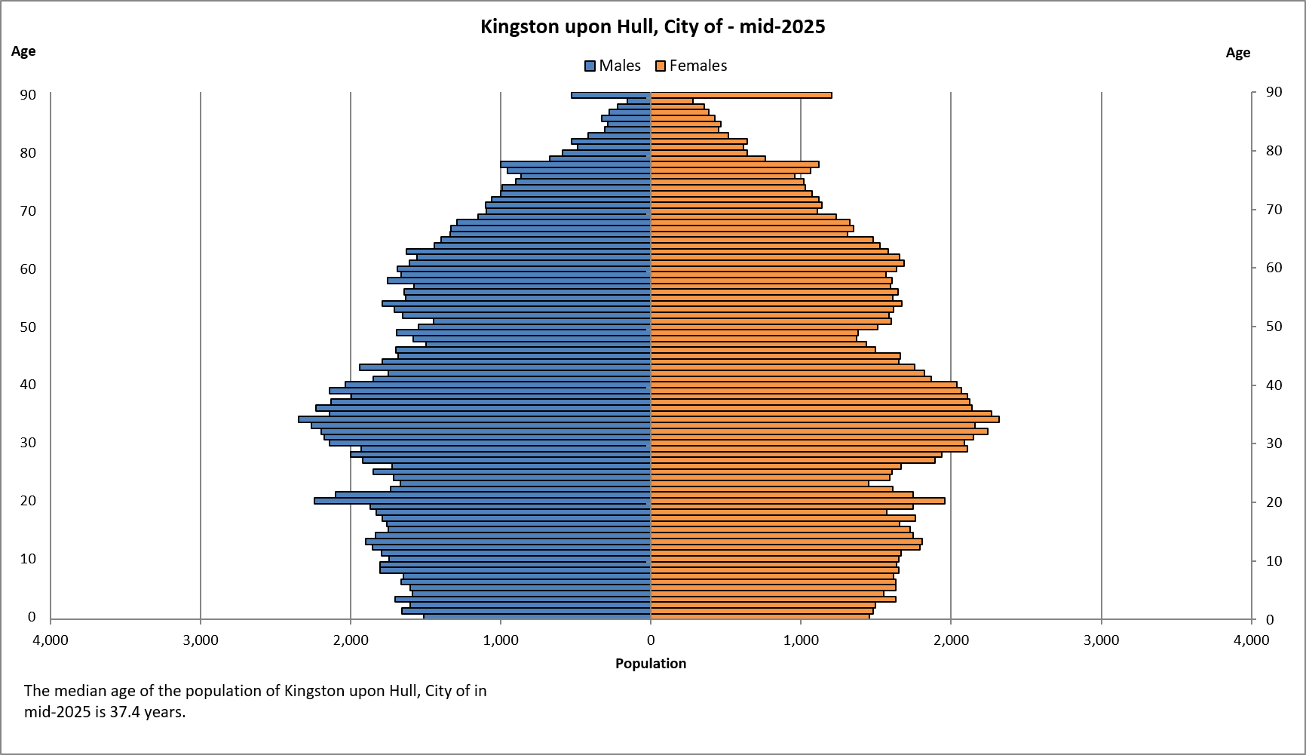

Table 2: Population Age Structure of Hull and England 2025

 | Hull |  | England
Age | Number | % | % | Diff
0 - 4 | 15,672 | 5.7% | 5.1% | 0.6%
5 - 9 | 16,695 | 6.1% | 5.6% | 0.5%
10 - 14 | 17,792 | 6.5% | 6.0% | 0.5%
15 - 19 | 17,451 | 6.4% | 5.9% | 0.4%
20 - 24 | 17,814 | 6.5% | 6.0% | 0.5%
25 - 29 | 18,626 | 6.8% | 6.6% | 0.2%
30 - 34 | 22,077 | 8.1% | 6.9% | 1.2%
35 - 39 | 21,342 | 7.8% | 7.0% | 0.8%
40 - 44 | 18,495 | 6.8% | 6.6% | 0.1%
45 - 49 | 15,496 | 5.7% | 6.1% | -0.4%
50 - 54 | 16,132 | 5.9% | 6.2% | -0.3%
55 - 59 | 16,303 | 6.0% | 6.6% | -0.6%
60 - 64 | 16,013 | 5.9% | 6.2% | -0.4%
65 - 69 | 13,204 | 4.8% | 5.2% | -0.4%
70 - 74 | 10,718 | 3.9% | 4.4% | -0.5%
75 - 79 | 9,312 | 3.4% | 4.2% | -0.8%
80 - 84 | 5,197 | 1.9% | 2.7% | -0.8%
85 - 89 | 3,188 | 1.2% | 1.6% | -0.5%
90 + | 1,730 | 0.6% | 0.9% | -0.3%

Table 3: Population Age Structure and Average Age 2025

 | Hull | England | Y&H | ER | NEL | NL
0 – 4 | 5.7% | 5.1% | 5.1% | 4.0% | 4.8% | 4.8%
5 – 14 | 12.6% | 11.6% | 11.7% | 10.2% | 12.1% | 11.4%
15 – 24 | 12.9% | 11.9% | 12.4% | 8.7% | 10.4% | 9.9%
25 – 34 | 14.9% | 13.5% | 12.9% | 10.3% | 11.7% | 11.1%
35 – 44 | 14.6% | 13.7% | 13.2% | 11.5% | 12.9% | 12.5%
45 – 54 | 11.6% | 12.3% | 11.9% | 12.0% | 11.6% | 11.8%
55 – 64 | 11.8% | 12.8% | 13.1% | 15.7% | 14.4% | 15.0%
65 – 74 | 8.8% | 9.6% | 10.0% | 13.5% | 11.2% | 11.8%
75 – 84 | 5.3% | 6.9% | 7.1% | 10.3% | 7.8% | 8.6%
85 + | 1.8% | 2.6% | 2.6% | 3.7% | 3.0% | 3.0%
Median Age | 37.4 | 40.6 | 40.8 | 49.9 | 43.4 | 45.2

Source: ONS Mid-Year Population Estimate 2025

  - Hull continues to have a distinctly younger age profile than England, Yorkshire and the Humber, and neighbouring authorities within the Humber sub-region. Residents aged under 45 account for approximately 60.7% of Hull's population, compared with 56.8% nationally and 55.3% regionally.

  - The city's age structure is characterised by relatively large proportions of children, young people and younger working-age adults. Hull is particularly over-represented in the 25-34 and 35-44 age groups, with the largest difference occurring amongst 30–34-year-olds, who comprise 8.1% of the population compared with 6.9% nationally.

  - Hull also has a higher proportion of residents aged 15-24 than England, Yorkshire and the Humber, and all neighbouring authorities, reflecting the influence of the city's higher education sector and its role as the principal urban centre within the Humber region.

  - In contrast, Hull has a lower proportion of residents aged 55 and over than England, the region and neighbouring authorities. The differences are particularly pronounced when compared with East Riding of Yorkshire, where older age groups form a much larger share of the population.

  - Residents aged 65 and over account for 15.9% of Hull's population, compared with 19.1% nationally, 19.7% regionally, and 27.5% in East Riding of Yorkshire, illustrating the significantly younger demographic profile of the city.

  - The greatest disparities are seen amongst the oldest residents. People aged 75 and over account for 7.1% of Hull's population, compared with 9.5% nationally, 9.7% regionally, and 14.0% in East Riding of Yorkshire.

  - As a result of this age structure, Hull has a substantially lower median age than comparator areas. The median age in Hull is 37.4 years, compared with 40.6 years nationally, 40.8 years regionally, 43.4 years in North East Lincolnshire, 45.2 years in North Lincolnshire, and 49.9 years in East Riding of Yorkshire.

  - Despite remaining younger than England and neighbouring authorities, Hull continues to experience population ageing. Recent population growth has increasingly been supported by international migration, helping to maintain relatively strong proportions of children and working-age adults while the number of older residents continues to increase over time.

Table 4: Population Change by Age, Hull 2005, 2015, 2024 and 2025

 | Hull  (2005) | Hull  (2015) | Hull (2024) | Hull (2025) | Long  05 – 25 | Med  15 - 25 | Annual  24 - 25
Age | Number | Number | Number | Number | % | % | %
0 - 4 | 14,357 | 18,172 | 16,093 | 15,672 | 9.2% | -13.8% | -2.6%
5 - 9 | 14,968 | 16,576 | 16,907 | 16,695 | 11.5% | 0.7% | -1.3%
10 - 14 | 16,946 | 13,598 | 17,954 | 17,792 | 5.0% | 30.8% | -0.9%
15 - 19 | 18,782 | 14,978 | 17,664 | 17,451 | -7.1% | 16.5% | -1.2%
20 - 24 | 23,607 | 23,070 | 17,134 | 17,814 | -24.5% | -22.8% | 4.0%
25 - 29 | 18,372 | 21,407 | 19,673 | 18,626 | 1.4% | -13.9% | -5.3%
30 - 34 | 18,256 | 19,261 | 22,860 | 22,077 | 20.9% | 14.6% | -3.4%
35 - 39 | 18,672 | 16,534 | 21,345 | 21,342 | 14.3% | 29.1% | 0.0%
40 - 44 | 18,691 | 17,175 | 17,990 | 18,495 | -1.0% | 7.7% | 2.8%
45 - 49 | 16,173 | 17,510 | 15,324 | 15,496 | -4.2% | -11.5% | 1.1%
50 - 54 | 14,444 | 17,725 | 16,520 | 16,132 | 11.7% | -9.0% | -2.3%
55 - 59 | 14,686 | 15,245 | 16,634 | 16,303 | 11.0% | 6.9% | -2.0%
60 - 64 | 10,462 | 13,107 | 15,858 | 16,013 | 53.1% | 22.2% | 1.0%
65 - 69 | 10,234 | 12,473 | 12,887 | 13,204 | 29.0% | 5.9% | 2.5%
70 - 74 | 9,344 | 8,402 | 10,789 | 10,718 | 14.7% | 27.6% | -0.7%
75 - 79 | 7,543 | 7,327 | 9,054 | 9,312 | 23.5% | 27.1% | 2.8%
80 - 84 | 5,608 | 5,409 | 5,114 | 5,197 | -7.3% | -3.9% | 1.6%
85 + | 4,014 | 4,742 | 4,927 | 4,918 | 22.5% | 3.7% | -0.2%

Source: ONS Mid-Year Population Estimate 2025

Long Term Trend

  - Over the last 20 years, Hull has experienced sustained population ageing, with the strongest growth occurring amongst older residents. The number of residents aged 60 and over increased from 47,205 in 2005 to 64,084 in 2025, an increase of 16,879 residents (+35.8%), and is now at its highest level on record.

  - The most significant growth has occurred amongst residents aged 60-64 (+53.1%), 65-69 (+29.0%), 75-79 (+23.5%) and 85+ (+22.5%), reflecting the ageing of larger generations born during the post-war period and a wider national trend towards population ageing.

  - The principal exception to this trend is the 80-84 age group, which remains 7.3% smaller than in 2005, making it the only older age group to record a long-term decline. However, numbers have begun to increase again in recent years as larger cohorts move through the age structure.

  - Alongside population ageing, Hull has experienced sustained growth amongst residents in their thirties. The number of residents aged 30-39 increased from 36,928 in 2005 to 43,419 in 2025, an increase of 6,491 residents (+17.6%), and is currently at its highest level on record.

  - Population growth amongst 25–29-year-olds formed an important part of Hull's recovery during the 2000s and early 2010s. Growth during this period coincided with increased international migration, including migration associated with EU accession countries. However, numbers peaked in 2017 and have subsequently declined to 18,626 in 2025, resulting in a reduction of 3,397 residents (-15.4%) from that peak.

  - Conversely, the most sustained long-term decline has occurred amongst 20–24-year-olds. Once one of Hull's largest age groups, numbers have fallen from 23,607 in 2005 to 17,814 in 2025, a decrease of 5,793 residents (-24.5%). This likely reflects a combination of smaller cohorts entering adulthood, changes in student populations and the continued tendency for some young adults and graduates to leave Hull for higher-skilled employment, career progression and wider labour market opportunities elsewhere.

Medium-Term Change

  - During the last decade, growth has become increasingly concentrated amongst both older residents and family-age populations. The strongest growth occurred amongst 10–14-year-olds (+30.8%), 35–39-year-olds (+29.1%), 70–74-year-olds (+27.6%), 75–79-year-olds (+27.1%) and 60–64-year-olds (+22.2%).

  - The number of 5–14-year-olds increased from 30,174 in 2015 to 34,487 in 2025, an increase of 4,313 residents (+14.3%), while the number of 15–19-year-olds increased by 2,473 residents (+16.5%) over the same period. Both age groups are now at, or close to, their highest levels for many years.

  - Growth has also been sustained amongst family and established working-age households. The number of residents aged 30-39 increased by 7,624 residents (+21.3%) between 2015 and 2025, while the number aged 40-44 increased by 7.7%. These age groups are now considerably larger than a decade ago and remain over-represented compared with England.

  - Historically, many of these age groups were associated with population decline in Hull and were linked to families moving to neighbouring authorities, particularly East Riding of Yorkshire, for reasons relating to housing, schools and neighbourhood choice. The sustained growth recorded during the last decade suggests improved retention of family-age households within the city, supported by housing development, economic investment, city centre regeneration and inward migration, although net internal migration losses to surrounding authorities continue to occur.

  - In contrast, the most significant declines during the last decade occurred amongst 20–24-year-olds (-22.8%) and 25–29-year-olds (-13.0%). This suggests that Hull continues to experience losses amongst younger adults, including students and graduates, as some residents move elsewhere for career progression and higher-skilled employment opportunities, even whilst retaining and attracting larger numbers of residents in their thirties and family-age groups

  - These trends mirror the wider findings from the 2025 population estimates. Growth has increasingly depended upon international migration offsetting weaker natural change, while population ageing continues to increase the proportion of residents in older age groups.

Recent and Annual Change

  - Although Hull's overall population declined by 1,470 residents between 2024 and 2025, change was not evenly distributed across the age structure, with some age groups continuing to grow strongly.

  - The largest increases were recorded amongst 20–24-year-olds (+680 residents), 40–44-year-olds (+505), 65–69-year-olds (+317) and 75–79-year-olds (+258). Growth amongst residents aged 65 and over therefore continued the long-established trend of population ageing within the city.

  - Conversely, the largest declines occurred amongst 25–29-year-olds (-1,047 residents), 30–34-year-olds (-783), 0–4-year-olds (-421) and 50–54-year-olds (-388). The decline in the youngest age groups is consistent with falling birth numbers and the weakening contribution of natural change to overall population growth.

  - The decline amongst residents aged 25-34 is particularly noteworthy. These age groups have historically been strongly influenced by international migration and were important contributors to Hull's population growth during the 2000s and early 2010s. Their decline in the latest year may indicate a moderation in the exceptionally strong international migration-driven growth observed nationally between 2022 and 2024.

  - The increase in 20–24-year-olds during the latest year represents a departure from the longer-term trend of decline and may reflect changes in student numbers, international migration or wider population movements following the post-pandemic period. Further years of data will be required to determine whether this represents the beginning of a longer-term change in direction.

  - Overall, the latest estimates continue to show the two dominant demographic trends affecting Hull: an increasingly ageing population, and a comparatively strong concentration of residents in family and established working-age age groups. While Hull remains younger than England, Yorkshire and the Humber and neighbouring authorities, recent population growth has become increasingly dependent on international migration as natural change has weakened and deaths have moved closer to, or exceeded, births.

- Dependency Ratios

  - The Dependency Ratio is an age-population ratio of those typically not in the labour force (the dependent part) and those typically in the labour force (the productive part). It can be used to measure the pressure on the productive population.

  - It is made up of two component parts; the Child Dependency Ratio (the ratio of residents aged 0 – 15 to those aged 16 – 64) and the Aged Dependency Ratio (the ratio of residents aged 65 + to those aged 16 – 64).

Table 5: Dependency Ratios 2025

 | Total DR | Child DR | Aged DR
Hull | 55.0 | 30.4 | 24.6
England | 58.7 | 28.4 | 30.3
Yorkshire & Humber | 60.7 | 29.0 | 31.7
East Riding | 75.9 | 26.8 | 48.2
North East Lincs | 67.4 | 30.5 | 36.9
North Lincs | 68.8 | 29.3 | 39.4
Bradford | 61.2 | 35.4 | 25.9
Leeds | 51.0 | 27.5 | 24.1
Sheffield | 52.4 | 26.4 | 26.1
Wakefield | 60.7 | 29.6 | 31.1
York | 50.5 | 21.1 | 29.4

Source: ONS Mid-Year Population Estimate 2025

  - Hull's total dependency ratio in 2025 was 55.0 dependents per 100 working-age residents, lower than both England (58.7) and Yorkshire and the Humber (60.7). This reflects Hull's relatively young population profile and comparatively large proportion of residents of working age.

  - Among neighbouring authorities, Hull recorded the lowest dependency ratio. The ratio was substantially higher in East Riding of Yorkshire (75.9), North Lincolnshire (68.8) and North East Lincolnshire (67.4), reflecting the considerably older age structure of these authorities.

  - Hull's child dependency ratio was 30.4, higher than England (28.4), Yorkshire and the Humber (29.0), East Riding (26.8) and North Lincolnshire (29.3), and broadly similar to North East Lincolnshire (30.5). This reflects Hull's comparatively high proportion of children and young people. Among the Yorkshire city comparators, only Bradford (35.4) recorded a higher child dependency ratio.

  - In contrast, Hull's aged dependency ratio was 24.6, substantially below the England average (30.3) and regional average (31.7). Hull also recorded the lowest aged dependency ratio of all neighbouring authorities and was lower than Bradford, Sheffield, Wakefield and York, reflecting the city's relatively small older population. Only Leeds (24.1) recorded a marginally lower aged dependency ratio.

  - The contrast between Hull's relatively high child dependency ratio and comparatively low aged dependency ratio reflects the city's distinctive demographic profile. Compared with neighbouring authorities, Hull contains a larger proportion of children, young people and younger working-age adults, but a much smaller proportion of residents aged 65 and over.

  - While Hull currently has a lower overall dependency burden than England, Yorkshire and the Humber, and neighbouring authorities, population ageing remains a significant long-term trend. Continued growth in the number of residents aged 65 and over, combined with weakening natural population change, is likely to increase the aged dependency ratio over time and bring Hull more closely into line with regional and national patterns.

Chart 3: Dependency Ratios, Hull 2005 - 2025

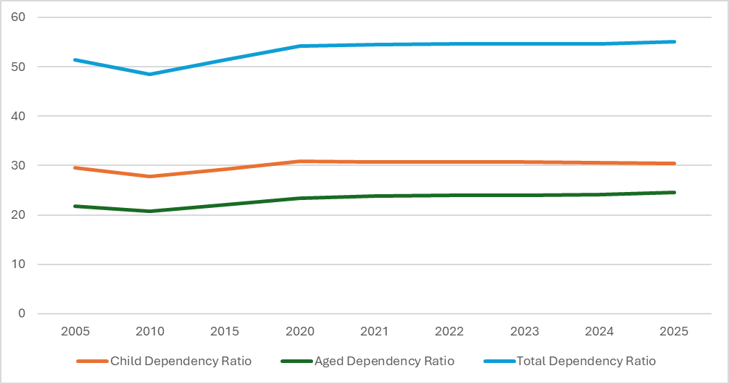

Source: ONS Mid-Year Population Estimate 2025

  - Hull's total dependency ratio increased from 51.4 in 2005 to 55.0 in 2025, meaning there are now approximately 55 dependents for every 100 working-age residents, compared with 51 twenty years ago.

  - The increase has been driven almost entirely by growth in dependent age groups rather than a decline in the working-age population. Between 2005 and 2025, the number of residents aged 65 and over increased by 6,606 (+18.0%), while the population aged 0-15 increased by 3,802 (+7.6%). In contrast, the working-age population (16-64) increased by 7,690 (+4.6%).

  - Population ageing has been the main driver of the long-term increase in dependency. The aged dependency ratio rose from 21.8 to 24.6 between 2005 and 2025 as the number of residents aged 65 and over reached its highest level on record.

  - The child dependency ratio has remained comparatively stable over the longer term, increasing from 29.6 in 2005 to 30.4 in 2025. This reflects growth in children and families over much of the last decade which broadly kept pace with growth in the working-age population.

  - The latest year saw a small increase in total dependency, from 54.7 to 55.0. This occurred because the working-age population fell by 1,337 residents (-0.8%), while the population aged 65 and over increased by 578 (+1.4%)..

  - The child dependency ratio fell slightly from 30.6 to 30.4 in the latest year, as the number of children aged 0-15 decreased by 711 residents (-1.3%), consistent with falling births and weaker natural population change.

  - The aged dependency ratio increased from 24.1 to 24.6 in the latest year, continuing the long-established ageing trend and indicating that growth amongst older residents is now the principal factor pushing dependency upwards.
  - Overall, Hull remains a relatively young city, but dependency is gradually increasing as the population ages and growth in the older population outpaces growth in the working-age population.

- Components of Population Change

Chart 4: Components of Population Change 2001 – 2025
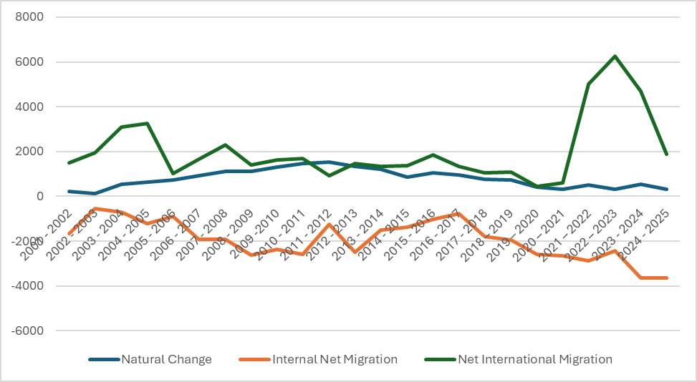
Source: ONS Mid-Year Population Estimates 2025, Components of Change

Table 6: Detailed Components of Population Change 2021, 2022, 2023, 2024 & 2025

 | Hull  2020 - 21 | Hull  2021 - 22 | Hull  2022 – 23 | Hull  2023 – 24 | Hull  2024 – 25
Population at Start | 267591 | 266516 | 269026 | 273245 | 274727
- Births | 3009 | 3202 | 3067 | 3119 | 2932
- Deaths | 2699 | 2704 | 2749 | 2590 | 2605
Natural Change | 310 | 498 | 318 | 529 | 327
- Internal In Migration | 11876 | 11769 | 11716 | 11713 | 11692
- Internal Out Migration | 14533 | 14662 | 14141 | 15373 | 15348
Net Internal | -2657 | -2893 | -2425 | -3660 | -3656
- International In Migration | 2481 | 6581 | 7998 | 7138 | 4506
- International Out Migration | 1877 | 1583 | 1745 | 2448 | 2636
Net International | 604 | 4998 | 6253 | 4690 | 1870
All Migration Net | -2053 | 2105 | 3828 | 1030 | -1786
Other | 668 | -93 | 73 | -77 | -11
Total Change | -1075 | 2510 | 4219 | 1482 | -1470
Population at End | 266516 | 269026 | 273245 | 274727 | 273257

Source: ONS Mid-Year Population Estimates 2025, Components of Change

Natural Change

  - Natural change has become a progressively weaker driver of population growth in Hull. Although births have continued to exceed deaths throughout the period, natural increase has fallen substantially from a peak of 1,538 people in 2011-12 to just 327 people in 2024-25.

  - The decline has been driven primarily by falling birth numbers. Annual births have reduced from around 3,900 per year in the early 2010s to 2,932 in 2024-25, while deaths have remained comparatively stable at around 2,500 to 2,800 per year.

  - This reflects wider demographic changes within the city, including lower fertility rates and an ageing population. As a result, natural change now contributes far less to population growth than it did a decade ago.

  - In the latest year, natural change remained positive but at one of the lowest levels recorded in the series. Births exceeded deaths by just 327 people in 2024-25, highlighting the continued weakening of this component of population change.

  - Overall, natural change is no longer sufficient on its own to sustain population growth, meaning the city has become increasingly reliant on migration to maintain its population.

Internal Migration

  - Hull has consistently lost population through internal migration throughout the entire series. Every year since 2001-02 has seen more people move from Hull to other parts of the UK than move into the city from elsewhere in the UK.

  - These losses have generally increased over time. Net internal migration losses typically ranged between 500 and 2,500 residents per year during the 2000s and early 2010s but have exceeded 2,500 per year in every year since 2019-20

  - The largest losses on record have occurred in the most recent years, reaching-3,660 in 2023-24 and-3,656 in 2024-25.

  - These sustained losses are likely to reflect a combination of factors, including families moving to surrounding authorities, particularly East Riding of Yorkshire, alongside some young adults leaving for higher education, career progression, employment and housing opportunities elsewhere.

  - Internal migration therefore remains Hull's largest recurring source of population loss, and recent population growth has occurred despite these losses rather than because they have reduced

International Migration

  - International migration has been the principal driver of Hull's population growth since the early 2000s. Positive net international migration has consistently offset losses through internal migration and has been central to the city's demographic recovery since its population low point in 2002.

  - The first major period of growth followed EU enlargement during the mid-2000s, when annual net international migration regularly exceeded 1,000 to 3,000 people.

  - A second and unprecedented period of growth occurred after the pandemic. Net international migration increased from 604 in 2020-21 to 4,998 in 2021-22, before reaching a record 6,253 in 2022-23.

  - These exceptionally high levels of international migration were the primary reason Hull experienced rapid population growth between 2021 and 2024, more than offsetting both persistent internal migration losses and the weakening contribution from natural change.

  - This reduction in international migration was the single biggest factor behind Hull's population decline between 2024 and 2025. With natural change contributing only modest growth and internal migration losses remaining close to record levels, migration gains were no longer sufficient to offset population losses elsewhere in the system.

  - Overall, Hull's recent population trends have become increasingly dependent on international migration. As natural change has weakened and internal migration losses have persisted, international migration has become the key factor determining whether the city's population grows or declines in any given year.

- Internal Migration Population Churn

  - Over the last 5 years, an average of approximately 11,750 people have moved to Hull each year from elsewhere in the UK and approximately 14,800 people have moved away from Hull each year to elsewhere in the UK.

Chart 5: Internal Migration by Age, Hull 2024 – 2025

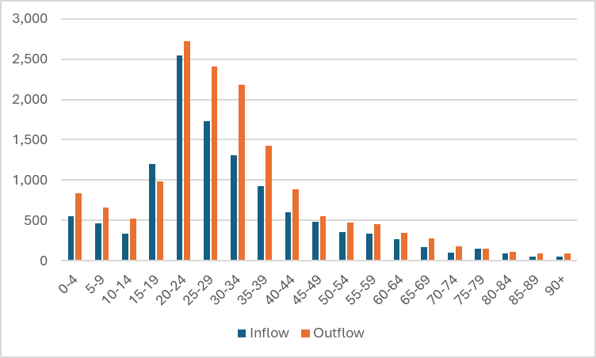

Source: ONS Mid-Year Population Estimates 2025, Internal Migration Estimates

  - Hull experiences net internal migration losses across almost every age group, with the exception of 15–19-year-olds, where inflows (1,195) exceed outflows (988), resulting in a net gain of approximately 207 residents. This is likely to reflect young people moving into the city for further and higher education

  - The largest volume of internal migration activity occurs amongst young adults aged 20-34, who account for over half of all internal migration movements.

  - Residents aged 25-39 account for the largest net internal migration losses overall. Combined, the city lost approximately 1,551 residents from the 25-39 age range, suggesting that many younger adults and families continue to move elsewhere after their early twenties during career formation and family-building stages of life.

  - Significant net losses are also evident amongst children and families. These patterns are consistent with family households moving out of Hull, often to surrounding authorities.

  - There are further, although smaller, net losses throughout the 40-74 age range, indicating that internal out-migration is not confined solely to younger adults.

  - The internal migration profile suggests a common life-course pattern whereby:

- Young people move into Hull during their late teens.
- Many leave during their twenties and thirties.
- Families with children continue to move out of the city.
- Smaller but persistent losses continue into later adulthood and retirement ages.

Table 7: Origin and Destination of Internal Migrants, All Ages, 2024 - 2025

Origin of All Internal Migrants to Hull |  | Destination of All Internal Migrants From Hull
Total: 11,692 |  | Total: 15,348
East Riding of Yorkshire | 32.9% | East Riding of Yorkshire | 39.2%
Leeds | 4.3% | Leeds | 4.7%
North Lincolnshire | 3.4% | North Lincolnshire | 3.2%
North Yorkshire | 2.9% | North Yorkshire | 2.5%
York | 2.6% | North East Lincolnshire | 2.0%
North East Lincolnshire | 2.5% | York | 1.9%
Bradford | 2.0% | Doncaster | 1.7%
Sheffield | 1.7% | Sheffield | 1.7%
Doncaster | 1.4% | Manchester | 1.5%
Kirklees | 1.4% | Scotland | 1.4%

Source: ONS Mid-Year Population Estimates 2025, Internal Migration Estimates

  - Unsurprisingly, the largest amount of population churn between Hull and other areas of the UK occurs with the East Riding.

  - A third (32.9%) of people who move to Hull from elsewhere in the UK, move from the East Riding.

  - Similarly, 39.2% of people who move from Hull to elsewhere in the UK, move to the East Riding.

  - Other areas with which Hull experiences a high level of overall population churn include Leeds, North Lincolnshire, North Yorkshire, North East Lincolnshire, York, Sheffield, Doncaster.

Table 8: Total Net Internal Migration With Hull, All Ages, 2024 - 2025

Largest Net Loss on Hull Population |  | Largest Net Gain on Hull Population
East Riding of Yorkshire | -2,171 | Bradford | +88
North East Lincolnshire | -214 | Kirklees | +38
Nottingham | -93 | Calderdale | +37
Rotherham | -93 | Lincoln | +25
Leeds | -87 | Chesterfield | +21
Manchester | -76 | Burnley | +21
Scotland | -70 | Lambeth | +19
Sheffield | -62 | Barking & Dagenham | +18
North Lincolnshire | -54 | Knowsley | +18
York | -48 | Stockport | +18

Source: ONS Mid-Year Population Estimates 2025, Internal Migration Estimates

  - The dominant feature of Hull's internal migration pattern is the exceptionally large net loss to East Riding of Yorkshire. The net loss of more than 2,100 residents is larger than all other flows combined and strongly suggests continuing suburbanisation and movement to nearby areas for housing, family and lifestyle reasons.

  - Hull experienced substantial net losses to neighbouring and nearby authorities. This indicates that much of Hull's internal migration loss occurs within its wider functional economic and housing market.

  - The strongest net gains came from West Yorkshire authorities, notably Bradford, Kirklees and Calderdale. This may partly reflect student migration, younger adult migration and movement within the Yorkshire region.

  - Migration with major cities is generally negative for Hull. The city recorded net losses to Leeds, Manchester, Sheffield, Nottingham and York, suggesting that some residents continue to leave Hull for higher education, graduate employment and career progression opportunities available within larger and more diverse labour markets.

  - London authorities appear amongst authorities from which Hull has the strongest net gains (Lambeth and Barking & Dagenham), indicating that Hull attracts at least some residents from higher-cost housing markets, potentially due to lower housing costs and university-related migration.

- Revisions to Previous Mid-Year Estimates

  - This release included revision to mid-2022, mid-2023, and mid-2024 population estimates to incorporate improved international migration data.

Table 9: Revisions to Previous Mid-Year Estimates, 2022 - 2024

 | Previous Mid-Year Estimate | Revised Mid-Year Estimates | Difference
2022 | 268,768 | 269,026 | 258
2023 | 273,069 | 273,245 | 176
2024 | 275,401 | 274,727 | -674

  - Most notably the mid-2024 mid-year population estimate has been revised downwards by 674 residents.

  - This is the result of an equivalent downwards revision to net international migration; including a reduction in international inward migration of over 500 people.

- Comparison With 2022 Based Population Projection

  - In June 2025, ONS published 2022 based sub-national population projections, which give an indication of future trends in the local population for the 25-year period from 2022 to 2047.

  - The 2022 based population projections use, as their base, the 2022 midyear population estimate for Hull, which is based off the 2021 Census.

Table 10: Comparison of Current Official Mid-Year Estimate and ABPE, 2024

 | 2022 Population Projection | Mid-Year Population Estimate | Difference Number
2022 | 268,677 | 269,026 | +349
2023 | 271,185 | 273,245 | +2,060
2024 | 272,994 | 274,727 | +1,733
2025 | 273,119 | 273,257 | +138

  - The 2022-based projections for 2025 prove highly accurate overall. Hull's population was projected to reach 273,119 by 2025, compared with an actual estimate of 273,257, a difference of just 138 people (0.1%).

  - Population growth immediately after 2022 was stronger than projected. The actual population exceeded the projection by around 2,060 people in 2023 and 1,733 people in 2024, reflecting higher-than-expected international migration levels during this period.

  - By 2025, actual population growth slowed and returned much closer to the projected trajectory. The reduction in international migration gains means the gap between projected and actual population has almost disappeared.

  - The projected age structure is broadly consistent with the eventual population estimates. The projections correctly anticipate declining numbers of children, growth in older age groups and continued population ageing, with the overall distribution by age remaining close to that observed in the mid-year estimates

  - The main differences occur amongst young adults, where actual population change was more volatile than projected. This reflects the impact of stronger-than-expected international migration, particularly in the years immediately following the pandemic, which temporarily increased population growth above projected levels

  - Overall, the comparison suggests that the assumptions underpinning the 2022-based projections remain robust. While migration patterns caused short-term divergence from the projected trajectory in 2023 and 2024, both the total population and age structure have largely converged with the projection by 2025.

- Future Releases

  - During October and November 2026, ONS will release these population estimates broken down into small geographical areas (Super Output Areas, health geographies, electoral wards, Parliamentary constituencies and National Parks).

  - A separate briefing paper will be produced when this data is released focused on population structure and population change at the local level.

Appendix A: Components of Population Change, Hull 2001 – 2025

Year | Start Pop | Birth | Deaths | Natural Change | Internal In Migration | Internal Out Migration | Internal Net Migration | International In Migration | International Out Migration | Net International Migration | Special | Unattr | Other Adjust | End Population
2001 - 2002 | 249913 | 2814 | 2584 | 230 | 9009 | 10690 | -1681 | 2714 | 1209 | 1505 | 39 | -543 | 0 | 249463
2002 - 2003 | 249463 | 2832 | 2712 | 120 | 9252 | 9788 | -536 | 3029 | 1082 | 1947 | 143 | -532 | -1 | 250604
2003 - 2004 | 250604 | 3154 | 2630 | 524 | 9325 | 10029 | -704 | 3890 | 803 | 3087 | 66 | -525 | -3 | 253049
2004 - 2005 | 253049 | 3195 | 2559 | 636 | 8862 | 10084 | -1222 | 4590 | 1336 | 3254 | -32 | -523 | -3 | 255159
2005 - 2006 | 255159 | 3341 | 2616 | 725 | 9046 | 9956 | -910 | 2844 | 1820 | 1024 | -7 | -491 | -3 | 255497
2006 - 2007 | 255497 | 3457 | 2526 | 931 | 8936 | 10841 | -1905 | 3324 | 1652 | 1672 | 47 | -478 | -3 | 255761
2007 - 2008 | 255761 | 3643 | 2518 | 1125 | 8584 | 10519 | -1935 | 3186 | 904 | 2282 | 2 | -484 | -5 | 256746
2008 - 2009 | 256746 | 3583 | 2483 | 1100 | 7837 | 10458 | -2621 | 2564 | 1177 | 1387 | -56 | -475 | -2 | 256079
2009 -2010 | 256079 | 3649 | 2342 | 1307 | 8167 | 10533 | -2366 | 2382 | 770 | 1612 | -11 | -446 | -1 | 256174
2010 - 2011 | 256174 | 3784 | 2329 | 1455 | 7828 | 10413 | -2585 | 2565 | 864 | 1701 | -106 | -516 | 0 | 256123
2011 - 2012 | 256123 | 3914 | 2376 | 1538 | 10336 | 11583 | -1247 | 2408 | 1479 | 929 | 91 | 651 | 0 | 258085
2012 - 2013 | 258085 | 3776 | 2423 | 1353 | 9599 | 12093 | -2494 | 2831 | 1352 | 1479 | -15 | 686 | 0 | 259094
2013 - 2014 | 259094 | 3622 | 2397 | 1225 | 10671 | 12190 | -1519 | 2882 | 1533 | 1349 | -24 | 771 | 0 | 260896
2014 - 2015 | 260896 | 3501 | 2637 | 864 | 10663 | 12029 | -1366 | 2796 | 1438 | 1358 | 271 | 688 | 0 | 262711
2015 - 2016 | 262711 | 3552 | 2515 | 1037 | 11151 | 12162 | -1011 | 3268 | 1405 | 1863 | 51 | 687 | 0 | 265338
2016 - 2017 | 265338 | 3562 | 2607 | 955 | 12802 | 13571 | -769 | 2910 | 1587 | 1323 | 10 | 709 | 0 | 267566
2017 - 2018 | 267566 | 3311 | 2557 | 754 | 11970 | 13774 | -1804 | 2897 | 1842 | 1055 | 10 | 642 | 0 | 268223
2018 – 2019 | 268223 | 3257 | 2515 | 742 | 12388 | 14326 | -1938 | 3254 | 2157 | 1097 | -26 | 651 | 0 | 268749
2019 – 2020 | 268749 | 3183 | 2774 | 409 | 11352 | 13949 | -2597 | 2906 | 2477 | 429 | -15 | 616 | 0 | 267591
2020 – 2021 | 267591 | 3009 | 2699 | 310 | 11876 | 14533 | -2657 | 2481 | 1877 | 604 | -27 | 695 | 0 | 266516
2021 – 2022 | 266516 | 3202 | 2704 | 498 | 11769 | 14662 | -2893 | 6581 | 1583 | 4998 | -93 | 0 | 0 | 269026
2022 – 2023 | 269026 | 3067 | 2749 | 318 | 11716 | 14141 | -2425 | 7998 | 1745 | 6253 | 73 | 0 | 0 | 273245
2023 - 2024 | 273245 | 3119 | 2590 | 529 | 11713 | 15373 | -3660 | 7138 | 2448 | 4690 | -77 | 0 | 0 | 274727
2024 - 2025 | 274727 | 2932 | 2605 | 327 | 11692 | 15348 | -3656 | 4506 | 2636 | 1870 | -11 | 0 | 0 | 273257

Appendix B: Population by Broad Age Group, Hull 2001 – 2025

Year | TOTAL | Aged 0 – 15 | Aged 16 – 64 | Aged 65 +
2001 | 249,913 | 53,027 | 159,195 | 37,691
2002 | 249,463 | 51,683 | 160,272 | 37,508
2003 | 250,604 | 50,730 | 162,662 | 37,212
2004 | 253,049 | 50,177 | 165,802 | 37,070
2005 | 255,159 | 49,831 | 168,585 | 36,743
2006 | 255,497 | 49,327 | 169,834 | 36,336
2007 | 255,761 | 48,471 | 171,349 | 35,941
2008 | 256,746 | 48,247 | 172,677 | 35,822
2009 | 256,079 | 48,173 | 172,310 | 35,596
2010 | 256,174 | 47,962 | 172,553 | 35,659
2011 | 256,123 | 48,340 | 171,876 | 35,907
2012 | 258,085 | 48,972 | 172,227 | 36,886
2013 | 259,094 | 49,622 | 171,732 | 37,740
2014 | 260,896 | 50,193 | 172,531 | 38,172
2015 | 262,711 | 50,857 | 173,501 | 38,353
2016 | 265,338 | 51,929 | 174,539 | 38,870
2017 | 267,566 | 52,623 | 175,737 | 39,206
2018 | 268,223 | 53,072 | 175,465 | 39,686
2019 | 268,749 | 53,608 | 174,925 | 40,216
2020 | 267,591 | 53,440 | 173,566 | 40,585
2021 | 266,516 | 52,928 | 172,470 | 41,118
2022 | 269,026 | 53,447 | 173,845 | 41,734
2023 | 273,245 | 54,222 | 176,728 | 42,295
2024 | 274,727 | 54,344 | 177,612 | 42,771
2025 | 273,257 | 53,633 | 176,275 | 43,349

