Insight Team Briefing  January 2024 | 

Census 2021 Workforce Commuting Patterns

1. Introduction

  - In December 2023, ONS released information from the 2021 Census on commuting patterns of individuals at local authority, Middle Super Output Area (MSOA) and Output Area (OA) geographies.

  - These datasets provide commuting flows between usual residence and place of work for people aged 16 year and over in employment or temporarily away from work in the week before Census 2021.

  - This data is available broken down by gender, age, approximate social grade, ethnic group, hours worked, passport held and car or van availability in the household.

2. Important Considerations

  - Census 2021 was conducted during the coronavirus (COVID-19) pandemic when there was a national lockdown and many travel restrictions were in place to stop the spread of the virus.

  - The pandemic severely impacted some people's ability to work, their working patterns, their workplace and method of travel to work.

  - Origin-destination data for travel to work therefore reflects a situation when many more people than at the time of the 2011 Census were working from home.

  - As part of the UK government's measures to reduce the impact of the coronavirus pandemic on the economy, businesses were able to furlough their workforce, this then affected the way furloughed people answered the travel to work questions.

  - In summary, it is unclear how representative the census statistics are of travel to work patterns on Census Day itself.

  - Furthermore, census data are a snapshot in time, but, given the impact of lockdown and furlough, the data may have limited utility in measuring pre- or post-pandemic travel patterns.

2. Actions

  - Services should consider the impacts on business planning, current and future policy development.

- Commuter Flows 2021

Table 1: Hull Commuting Summary (2021)

 | 2021 | %
Hull Residents 16+ in Employment | 117,807
- Work in UK But Not At or From Home | 86,086 | 73%
- Work Elsewhere in Hull | 60,598 | 51%
- Work East Riding | 18,706 | 16%
- Work North or North East Lincolnshire | 3,468 | 3%
- Work Rest of Yorkshire and Humber | 1,934 | 2%
- Work Rest of UK | 1,380 | 1%
- Mainly Work At or From Home / No Fixed Place | 31,060 | 26%
- Other (inc. Offshore and Outside UK) | 661 | 1%
Workplace Population | 118,347
- Live in UK But Not Working At or From Home | 87,287 | 74%
- Live Elsewhere in Hull | 60,598 | 51%
- Live East Riding | 21,836 | 18%
- Live North or North East Lincolnshire | 2,702 | 2%
- Live Rest of Yorkshire and Humber | 1,312 | 1%
- Live Rest of UK | 839 | 1%
- Mainly Work At or From Home / No Fixed Place | 31,060 | 26%
TOTAL INWARD | 26,689
TOTAL OUTWARD | 26,149
NET | 540

Source: ONS Origin and Destination Data, 2021 Census

- Summary of Commuting Flows in 2021

  - In 2021, Hull has a large degree of self-containment.

  - 76% of the resident population in employment either work elsewhere within the local authority boundary (51%) or work from home / no fixed place (26%).

  - At the time of the 2021 Census, 26,689 people commute into Hull to work and 26,149 people commute out.

  - As a result the work place population of Hull increases by 540 people compared to the usual resident-based population.

  - Of those 26,689 people working in Hull who originate from outside the local authority area; the significant majority largely live in the Yorkshire and Humber region (97%); specifically in the East Riding (82%).

  - Of those 26,149 people who live in Hull but work outside the local authority area; the significant majority work in the Yorkshire and Humber region (92%); specifically in the East Riding (72%)

- Comparison to Commuting Flows in 2011

  - Overall self-containment in Hull has increased slightly from 71% in 2011 to 76% in 2021.

  - However, this masks a significant change in the composition of self-containment.

  - The number of people in employment who live in Hull and work somewhere else in Hull has decreased by 18% (-12,856) from 73,454 in 2011 to 60,598 in 2021.

  - Conversely, the number of people in employment who live in Hull and work from home / no fixed place has increased by 142% (+18,243) from 12,817 in 2011 to 31,060 in 2021.

  - This is due to the high number of people working from home or furloughed at the time of the 2021 Census; the result of the coronavirus (COVID-19) pandemic which was ongoing at that time.

  - Total net in-commuting into Hull has fallen by 96% (-13,115) from 13,655 in 2011 to just 540 in 2021.

  - This reduction in net in-commuting to Hull has largely occurred due to a significant 31% (-11,964) decrease in total inward commuting into Hull for work from 38,653 in 2011 to 26,689 in 2021.

  - In particular, the number of people commuting into Hull for work from the East Riding has fallen 34% (-11,302) from 33,138 in 2011 to 21,836 in 2021.

  - Again, figures suggest a large proportion of individuals living in the East Riding (and the wider sub region), whose employment is based in Hull, were working from home or furloughed at the time of the 2021 Census.

  - Over the same period there was a 5% increase in total outward commuting of Hull residents for work outside the local authority boundary from 24,998 in 2011 to 26,149 in 2021.

  - In fact the number of people commuting out of Hull to the East Riding for work remained relatively unchanged over this period (+172, +1%).

  - This suggests that those people living in Hull but employed in the East Riding were largely unaffected by the increases in home working and furlough.

  - Looking at these figures paints a picture of the types of work undertaken by those individuals travelling into and out of the city.

  - East Riding residents employed in Hull are more likely to be in higher occupations, public sector roles, and based in office environments; and therefore more likely to have been able to work from home or to have been furloughed at the time of the 2021 Census.

  - Hull residents employed in the East Riding are more likely to work in elementary occupations, in plant and machine operative roles, often in agriculture or food manufacturing industries; and therefore less likely to have been able to work from home or to have been furloughed at the time of the 2021 Census.

- Commuting Into Hull For Work

  - At the time of the 2021 Census, 26,689 people commuted into Hull from outside the local authority boundary to work.

  - Table 2 shows clearly that the vast majority came from the Yorkshire and Humber region, specifically the East Riding of Yorkshire.

Table 2: Origin of In-Commuters (2021)

 | 2021 | %
All In-Commuters | 26,689
Yorkshire and Humber | 25,850 | 97%
- East Riding of Yorkshire | 21,836 | 82%
- North Lincolnshire | 1,857 | 7%
- North East Lincolnshire | 845 | 3%
- York | 266 | 1%
- Leeds | 204 | 1%
- Doncaster | 185 | 1%
- Selby | 130 | <1%
- Wakefield | 110 | <1%
- Other Yorkshire and Humber | 417 | 2%
Rest of UK | 839 | 3%

Source: ONS Origin and Destination Data, 2021 Census

6.3 Maps 1 and 2 on the following pages show the origin of in-commuters to Hull from the East Riding.

Map 1: Origin - East Yorkshire: Number of Commuters from East Riding Into Hull

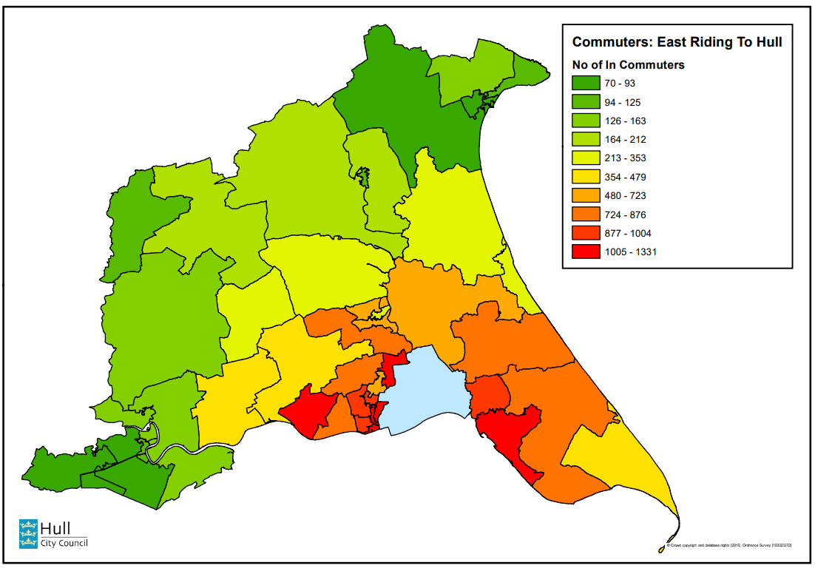
Map 2: Origin - East Yorkshire: Number of Commuters from East Riding Into Hull (With Parish Boundaries Overlaid)

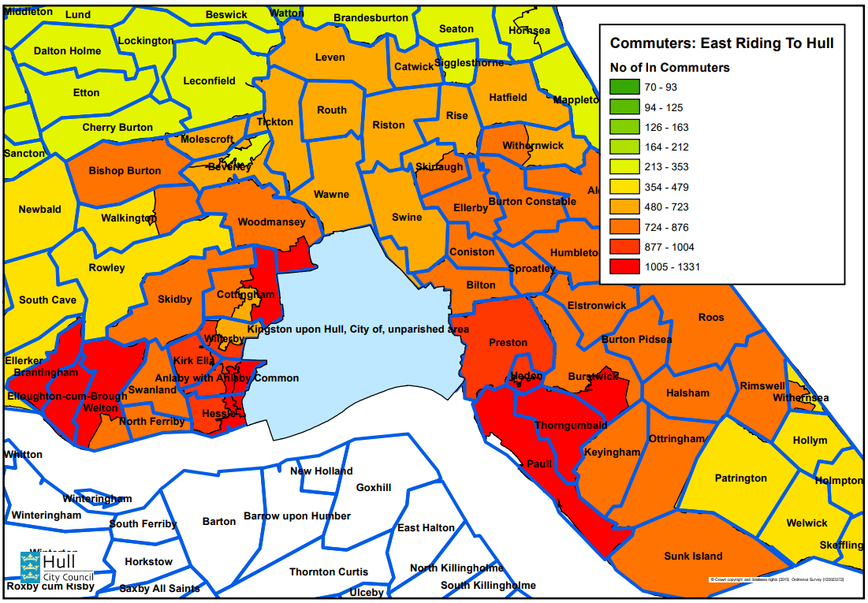

  - These maps show the highest numbers of in-commuters to Hull for work originate from just outside of the local authority boundary to the West and East of the city; most notably from Brough (5.0%), Anlaby Common (4.9%), Burstwick and Thorngumbald (4.7%), Hessle East and Anlaby South (4.5%), Cottingham East (4.2%), and Hedon and Preston (3.8%).

Map 3: Destination - Hull: Number of Commuters from Outside Hull Into Hull

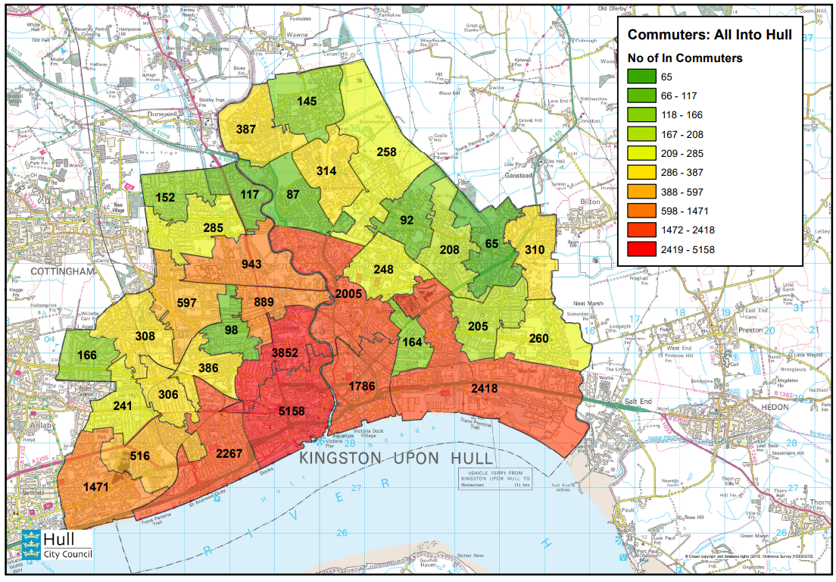

  - Map 3 (above) shows the total number of in-commuters to MSOA in Hull for work from outside of the local authority boundary. The map shows that in-commuting into Hull for work occurs largely to the City Centre (19.3%) and Sculcoates (14.4%) areas.

  - This is followed by the Southcoates Central and Docks (9.1%), Boulevard and St Andrews Quay (8.5%), Stoneferry and Sutton Fields (7.5%), Drypool and Victoria Dock (6.7%), and Anlaby Park and Pickering (5.5%) areas of the city.

  - In terms of in-commuting to Hull for work from outside the local authority boundary, the highest MSOA to MSOA commuting occurs between:

- Brough (ER) and Hull City Centre; 284
- Brough (ER) and Sculcoates; 263
- Anlaby Common (ER) and Hull City Centre; 259
- Hessle East & Anlaby South (ER) and Hull City Centre; 248
- Burstwick & Thorngumbald (ER) and Hull City Centre; 228
- Burstwick & Thorngumbald (ER) and Southcoates Central & Docks; 226
- Hedon and Preston (ER) and Southcoates Central & Docks; 201

- Commuting Out of Hull for Work

  - At the time of the 2021 Census, 26,149 people commuted out of Hull to outside the local authority boundary to work.

  - Table 5 shows that the majority of people who travel out of Hull to work do so to the Yorkshire and Humber region, specifically the East Riding of Yorkshire.

Table 5: Destination of Out-Commuters (2021)

 | 2021 | %
All Out-Commuters | 26,149
Yorkshire and Humber | 24,108 | 92%
- East Riding of Yorkshire | 18,706 | 72%
- North Lincolnshire | 2,598 | 10%
- North East Lincolnshire | 870 | 3%
- Ryedale | 596 | 2%
- York | 283 | 1%
- Leeds | 199 | 1%
- Selby | 178 | 1%
- Doncaster | 176 | 1%
- Wakefield | 153 | 1%
- Scarborough | 102 | <1%
- Other Yorkshire and Humber | 247 | 1%
Rest of UK | 1,380 | 5%
Offshore / Outside UK | 661 | 3%

Source: ONS Origin and Destination Data, 2021 Census

  - Maps 4 and 5 (overleaf) show the destination of out-commuters from Hull to the East Riding of Yorkshire for work.

Map 4: Destination - East Yorkshire: Number of Commuters From Hull Into East Riding

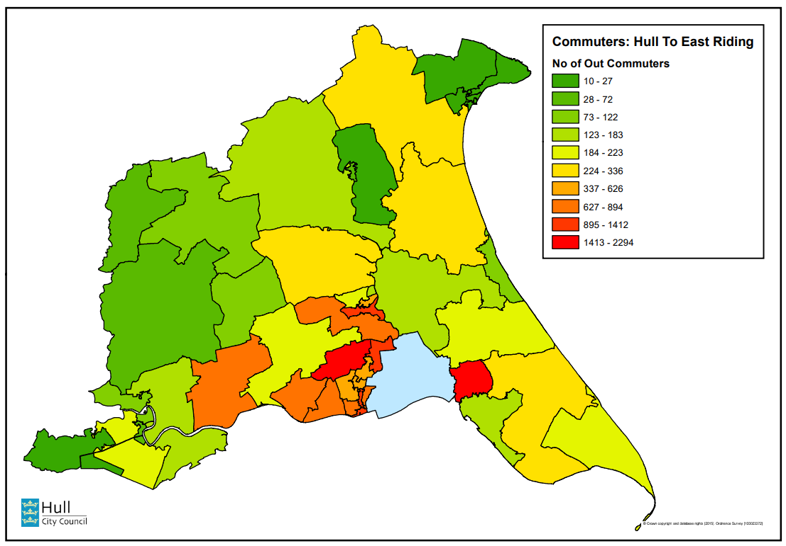

Map 5: Destination - East Yorkshire: Number of Commuters From Hull Into East Riding (With Parish Boundaries Overlaid)

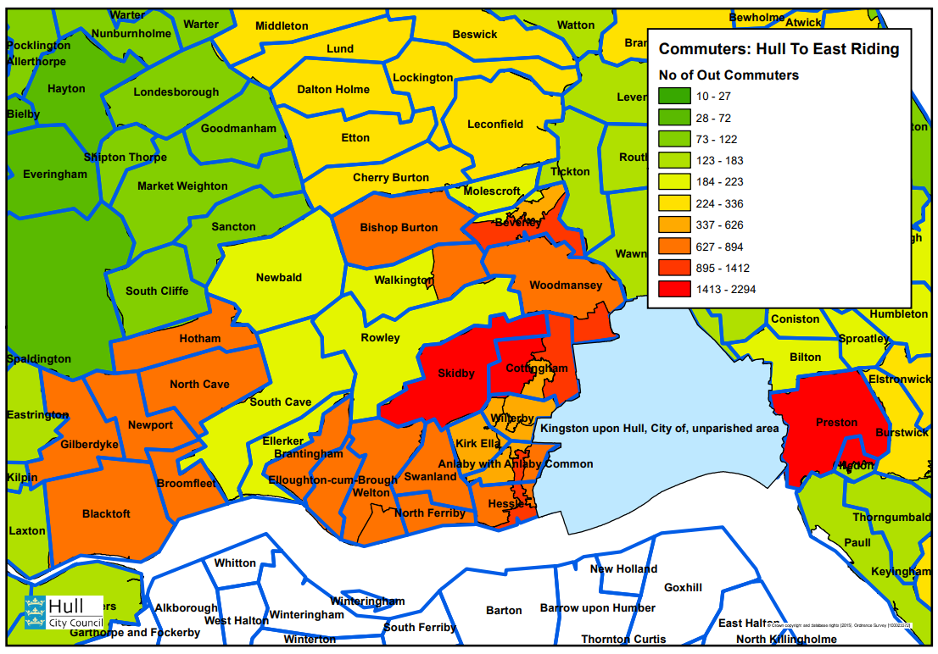

  - These maps show the highest numbers of out-commuters from Hull for work occurs to just outside of the local authority boundary to the West and East of the city; most notably to Hedon and Preston (8.8%), Hessle East and Anlaby South (8.2%), Cottingham West (5.4%), Beverley South (4.5%), and Cottingham East (4.5%).

Map 6: Origin - Hull: Number of Commuters from Hull to Areas Outside Hull

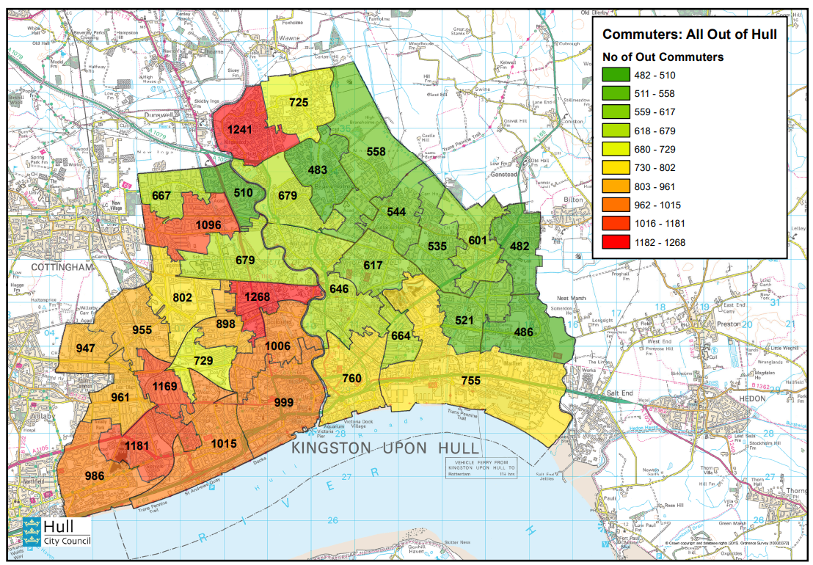

  - Map 6 (above) shows the total number of out-commuters from Hull to employment outside the local authority boundary. The map shows that out-commuting from Hull for work occurs largely from the Newland South (4.8%), Kingswood (4.7%), Gipsyville (4.5%), Newington (4.5%), Greenwood (4.2%), Boulevard and St Andrew’s Quay (3.9%), and Sculcoates (3.8%) areas of the city.

  - More people typically commute out of Hull for work from the West of the city, than the East of the city.

  - In terms of out-commuting from Hull for work outside the local authority boundary, the highest MSOA to MSOA commuting occurs between:

- Newland South and Hedon & Preston (ER); 215
- Sculcoates and Barton upon Humber (NL); 175
- Newland South and Barton upon Humber (NL); 167
- Sculcoates and Hedon & Preston (ER); 157
- Anlaby Park & Pickering and Hessle East & Anlaby South (ER); 144
- Bricknell West and Cottingham West (ER); 137

- Commuting Within Hull for Work

  - At the time of the 2021 Census, 60,598 people commuted within Hull for work i.e. they lived in Hull and were employed somewhere else in Hull (and not home working).

  - Maps 7 and 8 (overleaf) show the origin and destination of those commuting within Hull for work.

Map 7: Origin - Hull: Origin of Those Commuting Within Hull

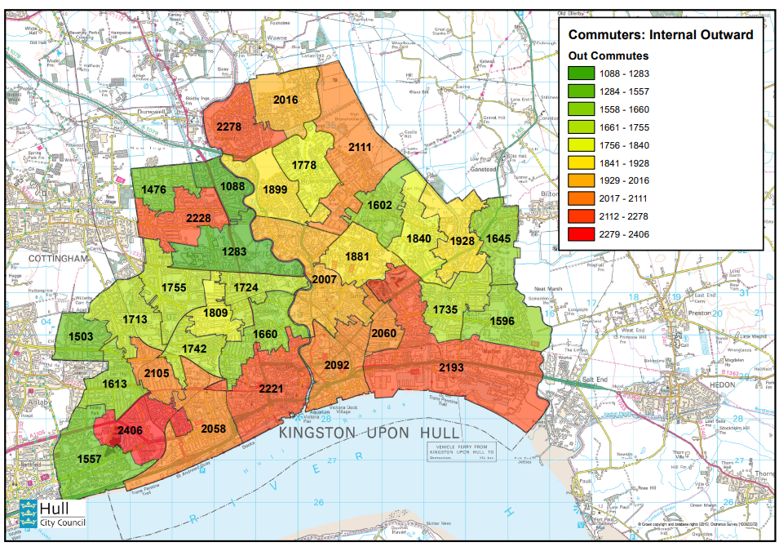

Map 8: Destination - Hull: Destination of Those Commuting Within Hull

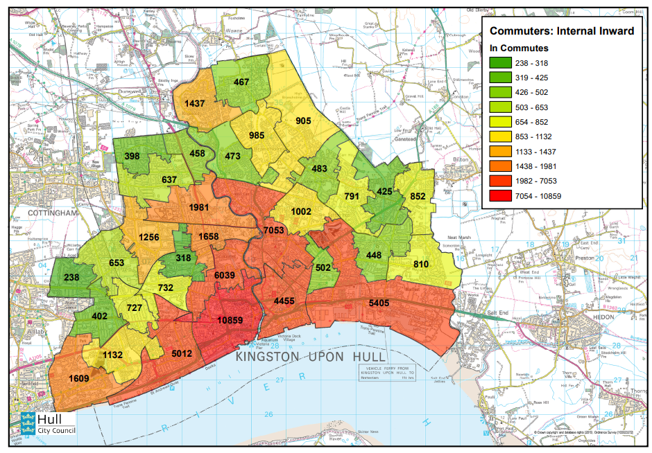

  - These maps show the highest numbers of out-commuters commuting within Hull for work occurs from the Gipsyville (4.0%), Kingswood (3.8%), Greenwood (3.7%), Hull City Centre (3.7%), and Southcoates Central and Docks (3.6%) areas of Hull.

  - Conversely the highest numbers of in-commuters commuting within Hull for work occurs to the Hull City Centre (17.9%), Stoneferry and Sutton Fields (11.6%), Sculcoates (10.0%), Southcoates Central and Docks (8.9%), Boulevard and St Andrews Quay (8.3%), and Drypool and Victoria Docks (7.4) areas of Hull.

  - In terms of commuting within Hull for work, the highest MSOA to MSOA commuting occurs between:

- Hull City Centre and Hull City Centre; 666
- Boulevard & St Andrews Quay and Boulevard & St Andrews Quay; 495
- Gipsyville and Boulevard & St Andrews Quay; 490
- Drypool and Victoria Dock and Hull City Centre; 483
- Southcoates Central & Docks and Southcoates Central & Docks; 425
- Gipsyville and Hull City Centre; 422
- Newland Avenues and Hull City Centre; 405
- Chanterlands Avenue and Hull City Centre; 403

- Home / No Fixed Place Working

  - At the time of the 2021 Census, 31,060 people either mainly worked from home or from no fixed place.

  - Maps 9 (below) shows the location of Hull residents who either mainly worked from home or from no fixed place.

Map 9: Mainly Work From Home / No Fixed Place

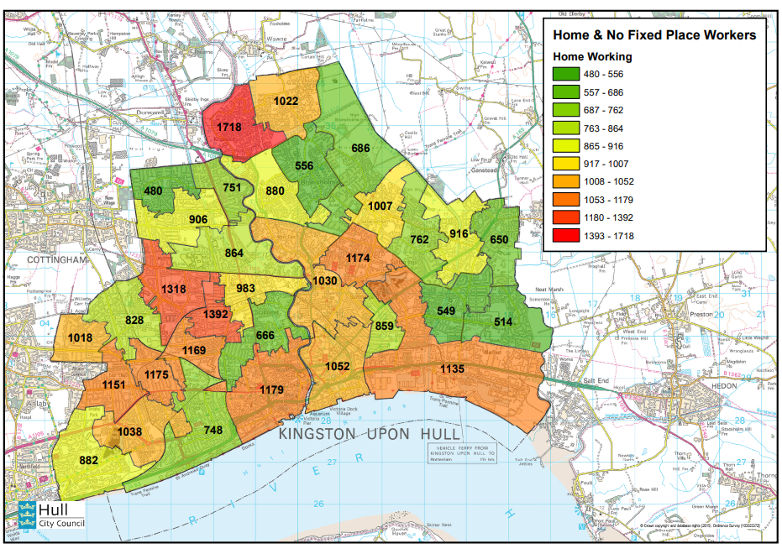

  - The largest number / proportion of Hull residents who mainly work from home from no fixed place can be found in Kingswood (1,718 or 5.5%).

  - This is followed by:

- Newland Avenues (1,392 or 4.5%)
- Bricknell East (1,318 or 4.2%)
- Hull City Centre (1,179 or 3.8%)
- Newington (1,175 or 3.8%)
- Sutton South (1,174 or 3.8%)
- Chanterlands Avenue (1,169 or 3.8%)
- Net Commuting Levels

  - At the time of the 2021 Census, 26,689 people commute into Hull to work and 26,149 people commute out.

  - As a result the work place population of Hull increases by 540 people compared to the usual resident-based population.

  - Maps 10 (below) shows net commuting levels at MSOA level i.e. the difference between total in commuting and total out commuting.

Map 10: Net Commuting Levels

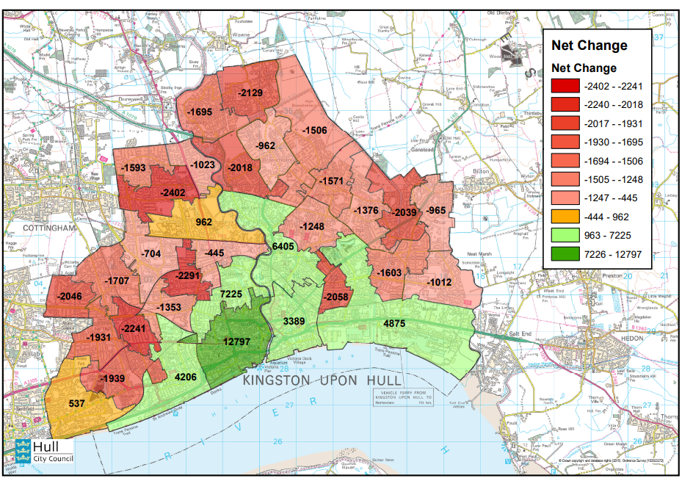

  - It shows that much of the city (25 out of 33 MSOA) experiences a net loss as a result of commuting i.e. more people commute out of the area than commute into the area.

  - This is most significant in the Greenwood (-2,402), Newland Avenue (-2,291), Newington (-2,241), North Bransholme (-2,129), Southcoates West (-2,058), Derringham (-2,046), Longhill (-2,039), and Bransholme West (- 2,018) areas of the city.

  - Conversely, 8 out of 33 MSOA experience a net gain as a result of commuting i.e. more people commute into the area than commute out of the area.

  - Unsurprisingly, Hull City Centre sees a significantly larger net gain than any other area (+12,797).

  - Other areas which experience a net gain include:

- Sculcoates (+7,225)
- Stoneferry and Sutton Fields (+6,405)
- Southcoates Central and Docks (+4,875)
- Boulevard and St Andrews Quay (+4,206)
- Drypool and Victoria Dock (+3,389)
- University and Newland North (+962)
- Anlaby Park and Pickering (+537)

- Self-Containment

  - 76% of the resident population in Hull employment either work elsewhere within the local authority boundary (51%) or work from home / no fixed place (26%).

  - Map 11 (below) shows the proportion of the population in employment at MSOA level who work within the same MSOA in which they live or work from home / no fixed place.

Map 11: MSOA Level Self-Containment

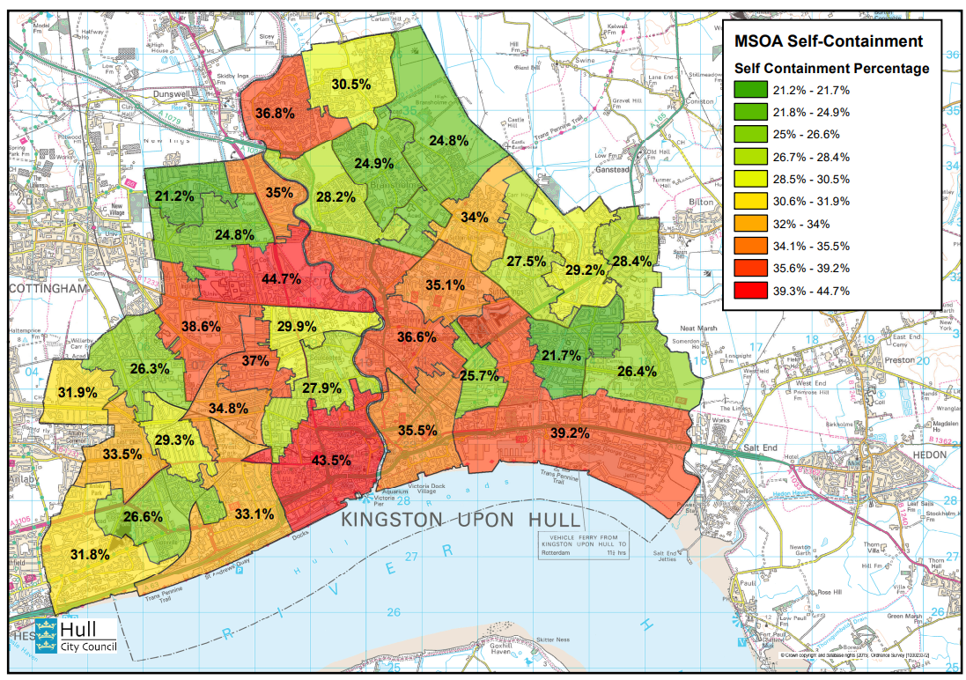

  - Self-containment at MSO level averages 31% i.e. an average of 31% of people in employment living within each MSOA either work within the same MSOA or work from home / no fixed place.

  - This self-containment is highest in:

- University and Newland North (44.7%)
- Hull City Centre (43.5%)
- Southcoates Central and Docks (39.2%)
- Bricknell East (38.6%)

  - Conversely, this self-containment is lowest in:

- Orchard Park (21.2%)
- Southcoates East (21.7%)
- Bransholme East (24.8%)
- Greenwood (24.8%)
- Bransholme Central (24.9%)

Table 5: Characteristics of Hull Commuters (2021)

 | Travel To Hull For Work | Travel From Hull For Work | Travel Within Hull For Work | Work Mainly At Home / No Faced Place
Gender and Age
Female | 48% | 43% | 53% | 38%
Male | 52% | 57% | 47% | 62%
Aged 16 – 24 | 10% | 13% | 13% | 10%
Aged 25 – 34 | 20% | 26% | 25% | 26%
Aged 35 – 44 | 21% | 22% | 21% | 23%
Aged 45 – 54 | 25% | 21% | 21% | 22%
Aged 55 – 64 | 20% | 16% | 17% | 16%
Aged 65 + | 4% | 2% | 3% | 3%
Social Grade
AB | 27% | 11% | 11% | 16%
C1 | 38% | 30% | 31% | 33%
C2 | 21% | 32% | 29% | 30%
DE | 9% | 23% | 23% | 14%
Does not apply | 6% | 5% | 6% | 6%
Ethnicity
Asian or Asian British | 3% | 3% | 3% | 3%
Black or Black British | 1% | 2% | 2% | 2%
Mixed or Multiple | 1% | 1% | 1% | 1%
White | 95% | 93% | 94% | 93%
Other | 1% | 2% | 1% | 1%
Hours Worked
Part Time: < 15 H | 6% | 6% | 8% | 9%
Part time: 16 – 30 H | 19% | 16% | 25% | 18%
Full Time: 31 – 48 H | 63% | 67% | 60% | 61%
Full Time: 48 + | 12% | 10% | 6% | 11%
Passport Held
United Kingdom | 91% | 70% | 77% | 82%
Ireland | <1% | <1% | <1% | <1%
EU Members | 2% | 19% | 10% | 7%
Rest of Europe | <1% | <1% | <1% | <1%
Other Country | 1% | 1% | 2% | 2%
No Passport | 5% | 9% | 11% | 9%
Household Car or Van Availability
No Cars or Vans | 4% | 17% | 20% | 14%
1 Car or Van | 25% | 42% | 42% | 40%
2 Cars or Vans | 48% | 31% | 29% | 35%
3 + Cars or Vans | 23% | 10% | 9% | 11%

Source: ONS Origin and Destination Data, 2021 Census

Note: AB grouped people who had higher and intermediate managerial, administrative and professional occupations. C1 grouped people who had supervisory, clerical, and junior managerial, administrative and professional occupations or who are full-time students. C2 grouped people who had skilled manual occupations. DE grouped people who had semi-skilled and unskilled manual occupations; unemployed and lowest grade occupations.

- Characteristics of Commuters

  - Individuals who travel into Hull for work tend to be older than average. They are more likely than average to be UK born and white, and to belong to higher social grades AB and C1. They are more likely than average to work full time, including a higher-than-average proportion who work over 48 hours a week. They have above average car ownership; with an above average proportion living in 2+ car households.

  - Conversely, individuals who travel out of Hull for work tend to be younger than average. They are more likely than average to have been born outside the UK, particularly in other EU countries, and to belong to lower social grades C2 and DE. They are more likely than average to work full time, although in this case they are more likely than average to work the typical 31 to 48 hours. Car ownership is broadly average.

  - Individuals who travel within Hull for work are more likely than average to be female and tend to be younger than average. They are more likely than average to work part time, including a higher-than-average proportion who work 16 – 30 hours a week. They have below average car ownership, with an above average proportion living in no car or one car households. These individuals are less likely than average to have a passport.

  - Finally, individuals who mainly work from hone / no fixed place are more likely than average to be male and include a higher proportion of 25 – 44-year-olds than average. They include a broadly average mix of ethnicities, nationalities, social grades, and working patterns; and car ownership is broadly average.

- Travel to Work Area

13.1 Following the 2011 Census, the ONS used 2011 commuting data to define a set of Travel to Work Areas (TTWAs) for the whole of the UK. The criteria was that Travel To Work Areas should show self-containment (i.e. the majority of people who live within that area also work in that area) and were broadly calculated on the basis that over 75% of the resident employed population should work in the area and over 75% of the workforce population should live in the area.

13.2 Map 12 (overleaf) shows that the 2011 Hull Travel To Work Area which is bounded by the Humber to the south, the coast to the east as far north as Hornsea, Driffield and Sledmere to the north, and Market Weighton and then Goole to the west.

Map 12: 2011 Hull Travel To Work Area (TTWA)

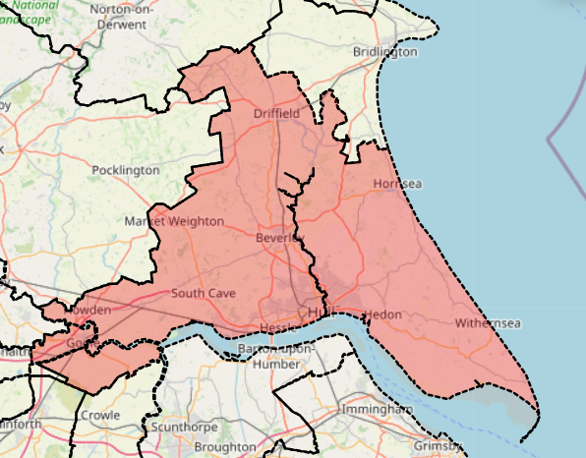

Source: ONS Travel to Work Areas, 2011

13.3 At present the ONS have not updated Travel to Work Area’s based on 2021 Census commuting data, and there are no details of any upcoming plans to do so.

  - However, it is possible to use the data at MSOA level to construct a model of Hull’s broader catchment area (see overleaf).

  - Those MSOA with a very high level of connection to Hull (over 70% of people in employment work in Hull) are defined as the Hull Inner Catchment Area. Other MSOA within the East Riding with a high level of linkage to Hull are defined as the Hull Middle Catchment Area (over 30% work in Hull) and Hull Outer Catchment Area (over 20% work in Hull).

  - Hull’s Inner Catchment Area is made up of the Kingston upon Hull local authority area.

  - The Middle Catchment Area includes Anlaby Common and Hessle East / Anlaby South to the west, Cottingham East to the north west, and Burstwick & Thorngumbald and Hedon & Preston to the east.

  - The Outer Catchment Area includes Aldbrough & Sproatley and Withernsea West & Keyingham to the east, and Willerby, Kirk Ella, Hessle West, North Ferriby & Swanland, Cottingham West, and Cottingham South & North Ella to the west.

Map 13: Hull MSOA Modelled Catchment Area

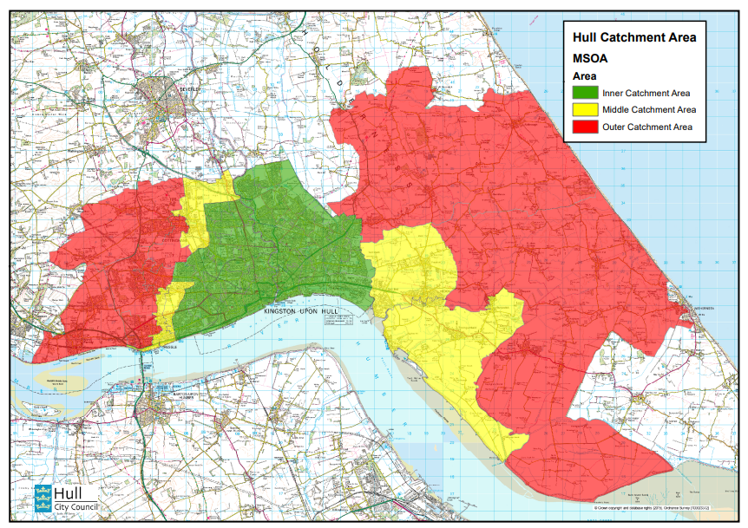

8. Conclusions

  - Services should consider the impacts on business planning, current and future policy development.

Contact Officers: Richard Morfitt
Telephone No: 61 (3465)
Officer Interests: None

Appendix A: Hull MSOA With Names



