2021 Based Hull Customer Segment Descriptions

Segment A: Single Older People and Pensioners in Social Rented Flats
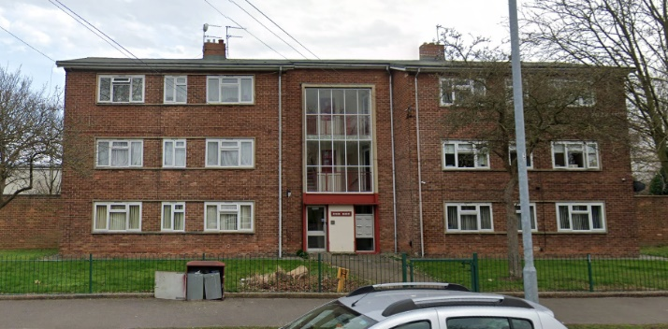  - Bricknell West  - Ings  - Southcoates East  - Drypool & Victoria Dock  - Hull City Centre | 2.1% of Hull Population  3.4% of Hull Households
 | This group is defined by the above average proportion of single older people and pensioners (aged 60+) living in small LA and other social rented purpose-built flats. Health is a particular issue for this group - an above average proportion reports their health as bad and / or experience a limiting long-term illness or disability for which regular care or support is required.
Neighbourhood Priorities:

- Activities / facilities for teenagers *****
- Access to council services ****
- Access to health services ***
- Clean streets ***
- Levels of crime and ASB ***
- Affordable, suitable housing *
- Motorcycle related nuisance *
Segment B: Ethnically Diverse Singles in Social Rented Flats
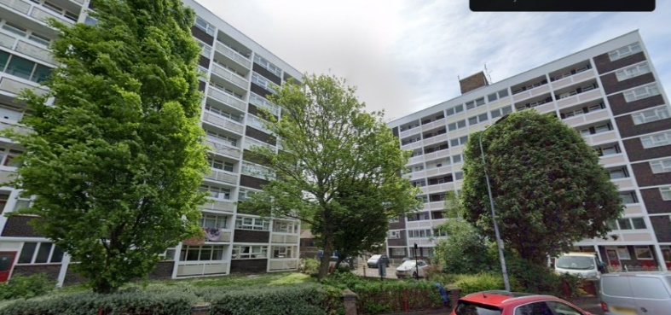  - Hull City Centre  - Sculcoates | 3.4% of Hull Population  3.7% of Hull Households
 | Containing an above average proportion of ethnically diverse single people, from around the world, living in LA and other social rented purpose-built flats. Economic inactivity and unemployment are high; including long term unemployment and those who have never worked. Health is also an issue with a high proportion of people in poor health and a high Standardised Illness Ratio.
Neighbourhood Priorities:

- Levels of pollution *****
- Levels of crime and ASB ***
- Access to health services ***
- Clean streets ***
- State of roads and pavements *
- Levels of congestion *
- Activities / facilities for older people *
- Begging / vagrancy *
- Availability of parking *

Segment C: Young Families Renting From Council In Areas of High Deprivation
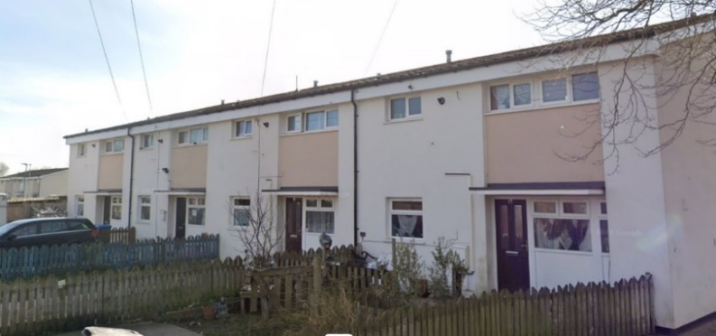  - Greenwood  - Orchard Park  - Greatfield | 19.0% of Hull Population  15.9% of Hull Households
 | Living in the most deprived areas of the city, this group contains an above average proportion of young families with dependent children, living in smaller LA rented housing – including a high proportion of lone parents. Qualifications are typically lower, and there is a high proportion of residents who are economically inactive looking after home or family.
Neighbourhood Priorities:

- Motorcycle related nuisance ********
- Levels of crime and ASB *****
- Access to health services ***
- Clean streets ***
- Activities / facilities for teenagers ***
- Affordable, suitable housing ***
- Access to council services *
- Activities / facilities for children *
- State of roads and pavements *

Segment D: Older Families on Tradition Council Estates
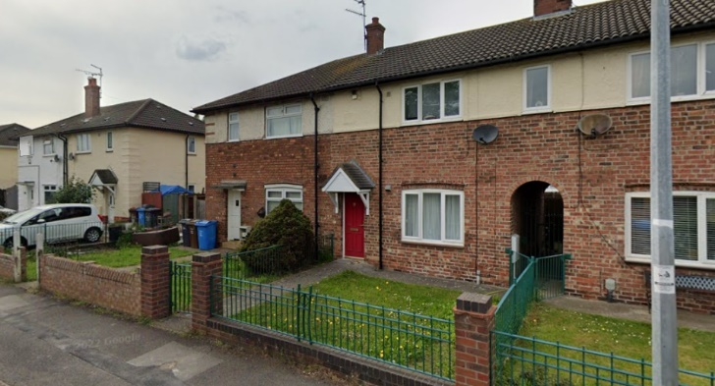  - Bransholme Central  - Gipsyville  - Soutcoates East  - Bricknell West | 15.7% of Hull Population  15.8% of Hull Households
 | Made up of older families living in a mixture of LA rented and owner-occupied terraces and semidetached properties on Hull’s older / more traditional estates. Although unemployment / economic activity is relatively high – this group work hard in routine / semi routine occupations and caring, leisure and service occupations to make a more comfortable life for themselves.
Neighbourhood Priorities:

- Access to health services ***
- Levels of crime and ASB ***
- Clean streets ***
- State of roads and pavements ***
- Access to council services ***
- Motorcycle related nuisance ***
- Affordable, suitable housing *
- Activities / facilities for teenagers *
- Parks and open spaces *

Segment E: Low Income Residents in High Density Private Rented Terraces
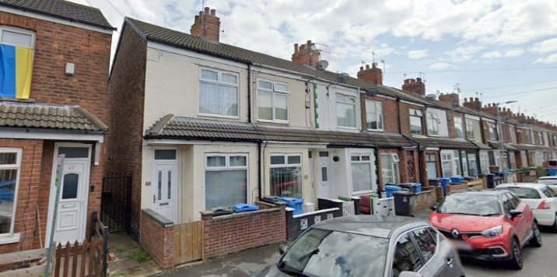  - Boulevard and St Andrew  - Newington  - Drpool and Victoria  - Stoneferry and Sutton Fields | 5.7% of Hull Population  6.0% of Hull Households
 | Containing low-income young singles and families in densely packed mostly private rented terraces, these neighbourhoods provide a relatively cheap entry point into the housing market for those who do not qualify for social housing. An above average proportion of residents were born outside the UK; particularly in EU8 and EU2 countries but have chosen to settle in Hull.
Neighbourhood Priorities:

- Access to health services ***
- Clean streets ***
- Levels of crime and ASB ***
- Affordable, suitable housing *
- Green and planted areas *
- Parks and open spaces *
- State of roads and pavements *
- Level of congestion *

Segment F: Traditional Older Couples in Owner Occupied Semidetached Houses
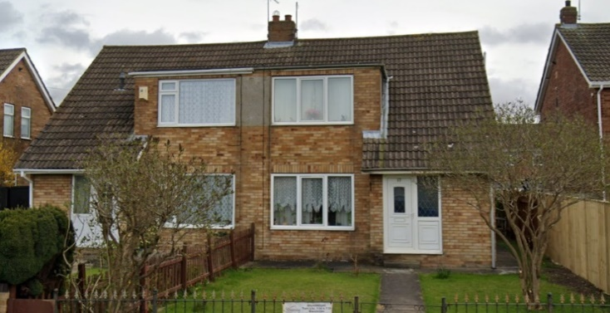  - Sutton South / Sutton North  - Haworth Park  - Bransholme West | 15.1% of Hull Population  14.5% of Hull Households
 | This group contains a high proportion of older (aged 55+), white UK born, “traditional” couples living in low density owner occupied, typically semidetached houses. Relatively healthy (although more likely to provide unpaid care), moderately educated, and mixing retired and economically active. Car ownership is high, and those in employment are more likely to work as intermediate professionals and managers / directors; particularly in public service, skilled trades, and construction.
Neighbourhood Priorities:

- State of roads and pavements ********
- Level of congestion *****
- Access to health services ***
- Levels of crime and ASB ***
- Clean streets ***
- Parks and open spaces ***
- Public transport *

Segment G: Educated Professionals in Large Houses in Areas of Relative Prosperity
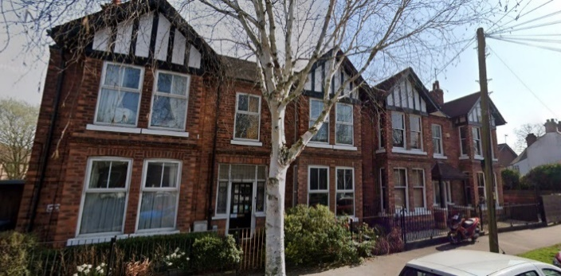  - Chanterlands Avenue  - Newland Avenues  - Drypool and Victoria Dock | 4.6% of Hull Population  5.0% of Hull Households
 | This group contains mostly working age adults living in a mixture of large, owner occupied and private rented, houses and flats in areas of relative prosperity. With above average levels of higher qualifications; significant proportions are employed in varying professional and technical occupations, and in managerial roles, often within the public and finance / insurance sectors. Levels of self-employment are above average and a high proportion work from home.
Neighbourhood Priorities:

- Access to health services *****
- Begging / vagrancy *****
- Public transport *****
- Levels of crime and ASB ***
- Clean streets ***
- Education provision ***
- Parks and open spaces ***
- Levels of pollution ***

Segment H: Economically Active Singles and Families in Owner Occupied Terraces
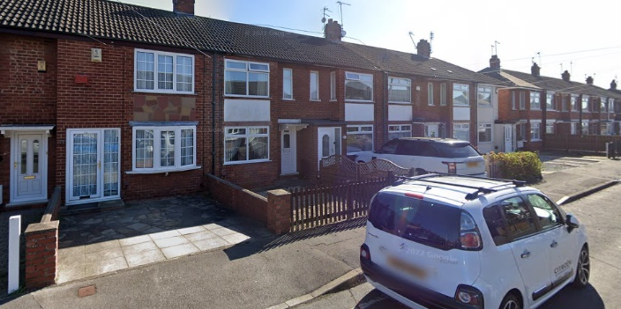  - Derringham  - Southcoates West / Central  - Newington | 15.9% of Hull Population  15.4% of Hull Households
 | This group is made up of mostly white UK born working age singles and families in owner occupied terraced housing. Moderately educated, most are economically active in a range of lower and intermediate professional and technical occupations across various industries. More specifically, this includes a high proportion employed in administration and secretarial roles, or in skilled trades, most notably in construction.
Neighbourhood Priorities:

- Level of congestion *****
- Access to health services ***
- Levels of crime and ASB ***
- Clean streets ***
- State of roads and pavements ***
- Education provision ***
- Affordable, suitable housing *

Segment I: Young Couples and Families in Owner Occupied Detached and Semidetached
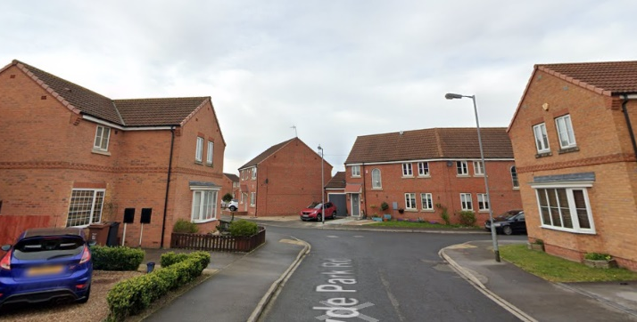  - Kingswood  - North Bransholme | 7.6% of Hull Population  7.4% of Hull Households
 | Typically younger working age couples, some with young children, this group live in large owner occupied detached and semidetached housing in ‘desirable’ family neighbourhoods. Relatively healthy, well educated, and with high multiple car ownership, economic activity is high and many work in professional, associate professional, and managerial occupations; often in the public sector
Neighbourhood Priorities:

- Levels of crime and ASB *****
- State of roads and pavements *****
- Access to health services ***
- Clean streets ***
- Parks and open spaces **
- Sports and leisure facilities *
- Level of congestion *

Segment J: University Students in Private Rented Terraces and Flats
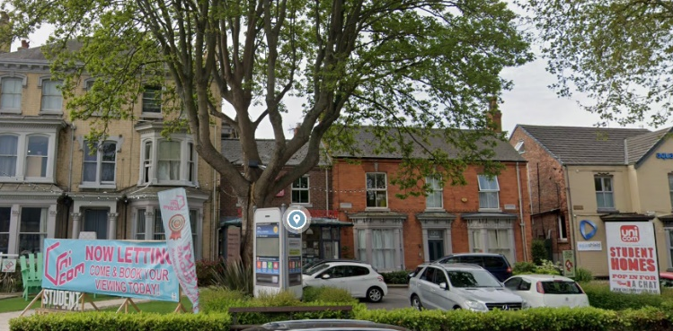  - University and Newland North | 2.1% of Hull Population  2.6% of Hull Households
 | This group consists largely of diverse single young adults from the UK and abroad, living in private rented terraces and flats whilst studying towards a degree at the university. Relatively new to Hull, and living in communal wholly student households, or alone, those who work are typically employed in the hospitality industry or in customer service.
Neighbourhood Priorities:

- Access to health services ***
- Clean streets ***
- Affordable, suitable housing ***
- Begging / vagrancy **
- Levels of crime and ASB *
- State of roads and pavements *
- Green and planted areas *
- Good community spirit *

Segment K: Young Single Professionals in Private Rented Flats
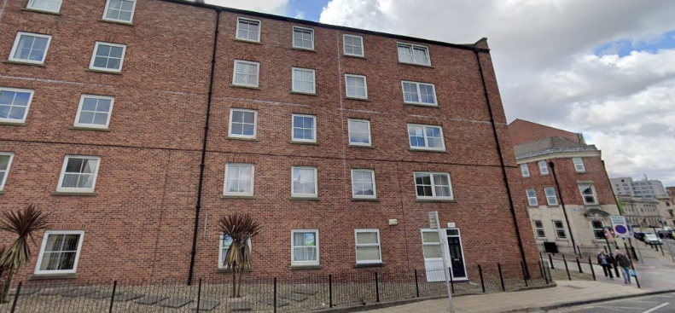  - Hull City Centre | 1.9% of Hull Population  3.2% of Hull Households
 | This group is made up of younger, ethnically diverse single people (with no children) living in private rented larger flats in purpose-built and converted buildings. This group also includes a high number of second homes used by people working away from home. Highly educated, often born outside Hull, and employed in higher professional roles in the public or finance / insurance sector, they are often recent university graduates and in the early / mid stages of their career.
Neighbourhood Priorities:

- Begging / vagrancy ****
- Good community spirit ***
- Levels of crime and ASB ***
- Access to health services ***
- Parks and open spaces ***
- Clean streets *
- Levels of congestion *
- Active community *
- Level of pollution *
- Shopping facilities *

Segment L: Diverse Singles and Couples in Private Renting Terraces and Flats
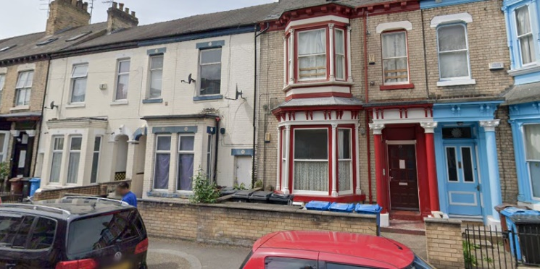  - Newland South  - Sculcoates  - Boulevard and St Andrews  - Newland Avenues | 6.9% of Hull Population  7.2% of Hull Households
 | Typically young singles and couples living in a mixture of high density, often crowded, private rented terraces and flats in ethnically diverse, but economically challenged, areas. A high number were born outside the UK; and include recent economic migrants to Hull from EU8 and EU2 countries, as well as more established ethnic communities. Many are employed in routine occupations and process, plant, and machine operative roles; most notably in manufacturing.
Neighbourhood Priorities:

- Access to health services ***
- Levels of crime and ASB ***
- Clean streets ***
- State of roads and pavements ***
- Active community ***
- Begging / vagrancy ***
- People get on *
- Good community spirit *
- Affordable, suitable housing *

